**National Center for Biotechnology Information (NCBI)**

1.Download the gene sequence and mRNA sequence of Leptin and Leptin Receptor gene of Human, Mouse and Rat, Cattle and Pig. Save it in a separate folder and name it properly.

i. What is the chromosomal location of (i) Leptin and (ii) Leptin Receptor in these organisms?

ii. Compare the length of the gene sequences of (i) Leptin and (ii) Leptin Receptor in these organisms?

iii. Write the accession number of (i) Leptin and (ii) Leptin Receptor in these organisms?

iv. How many exons do you find in the gene sequence of (i) Leptin and (ii) Leptin Receptor in these organisms?

v. Write the start and end position of the exons in the gene sequence of (i) Leptin and (ii) Leptin Receptor in these organisms?

vi. Is there any publication related to these sequences? If so, quote it.

Answer:

NCBI Home Page

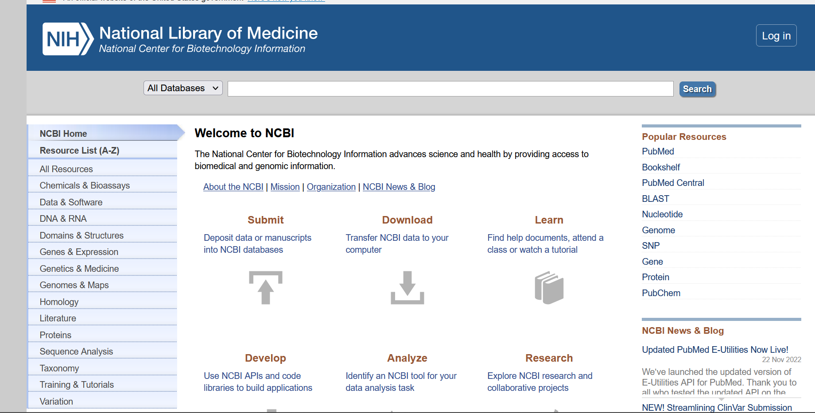

Organism: Human

|  |  |  |
| --- | --- | --- |
|  | Leptin | Leptin Receptor |
| Chromosomal Location | Chromosome 7  NC_000007.14 (128241278..128257629) | Chromosome 1  NC_000001.11 (65420652..65641559) |
| Length of Gene Sequence | 16352 bp | 220908 bp |
| Accession Number | NC_000007 | NC_000001 |
| Number of Exons | 3 | 24 |
| Start and End positions of Exons |  | complement(155303..157153)  complement(157607..157848) |
| Publications | REFERENCE - 2 (bases 1 to 16352)  AUTHORS - Hillier,L.W., Fulton,R.S., Fulton,L.A., Graves,T.A., Pepin,K.H., Wagner-McPherson,C., Layman,D., Maas,J., Jaeger,S., Walker,R.  TITLE - The DNA sequence of human chromosome 7  JOURNAL - Nature 424 (6945), 157-164 (2003)  PUBMED - 12853948 | REFERENCE - 1 (bases 1 to 220908)  AUTHORS - Gregory,S.G., Barlow,K.F.,McLay,K.E., Kaul,R., Swarbreck,D.,Dunham,A., Scott,C.E., Howe,K.L.,Woodfine,K.,Spencer,C.C.,  Jones,M.C., Gillson,C., Searle,S.,  TITLE - The DNA sequence and biological annotation of human chromosome 1  JOURNAL - Nature 441 (7091), 315-321 (2006)  PUBMED - 16710414 |

Hits Page

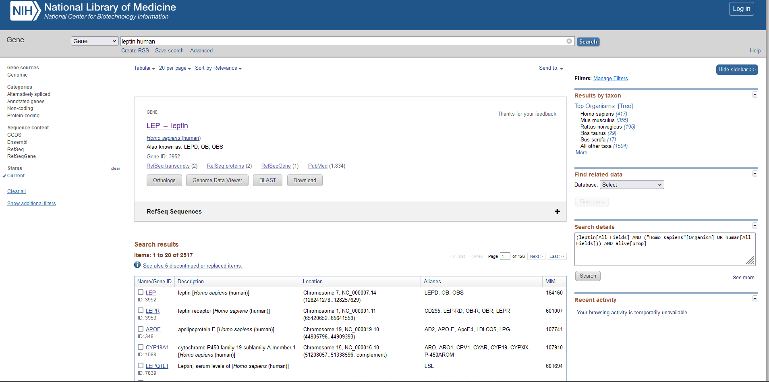

Chromosome location – Leptin Human

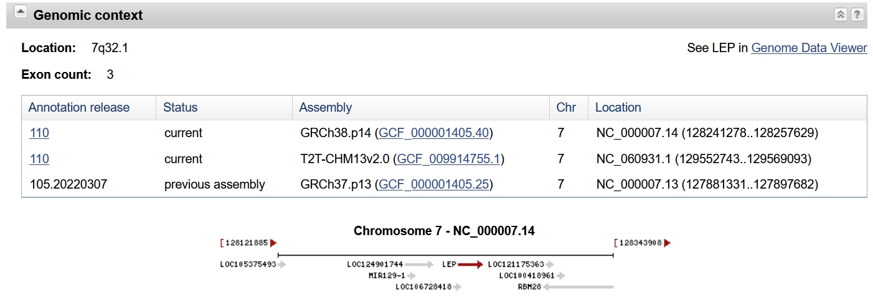

Genbank

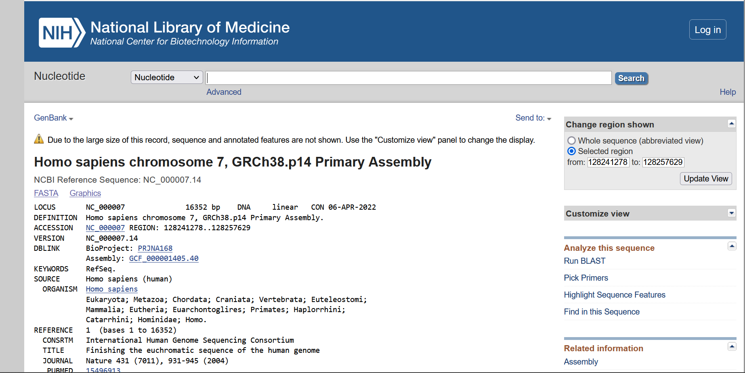

Gene Sequence – Leptin Human

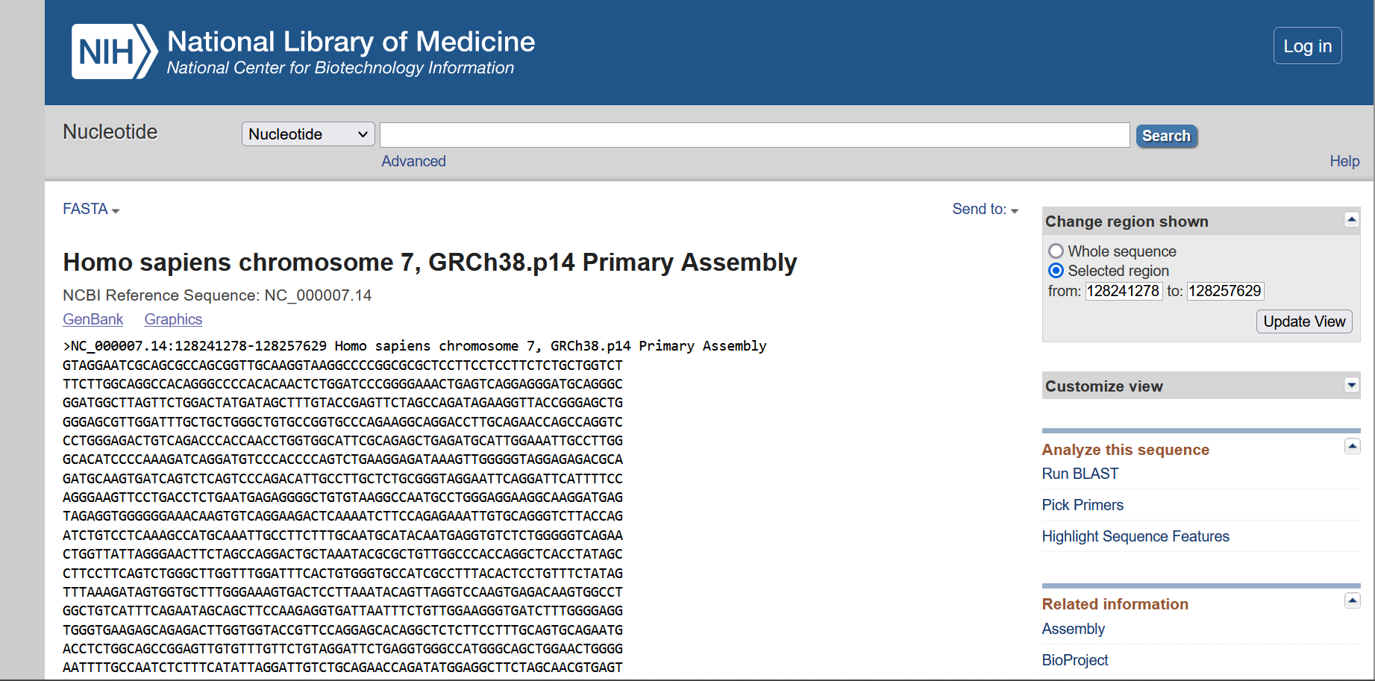

mRNA Sequence – Leptin Human

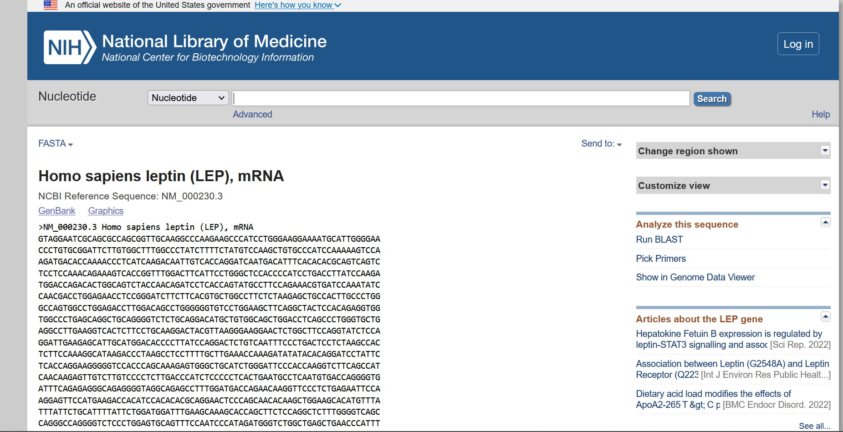

Chromosome location – Leptin receptor Human

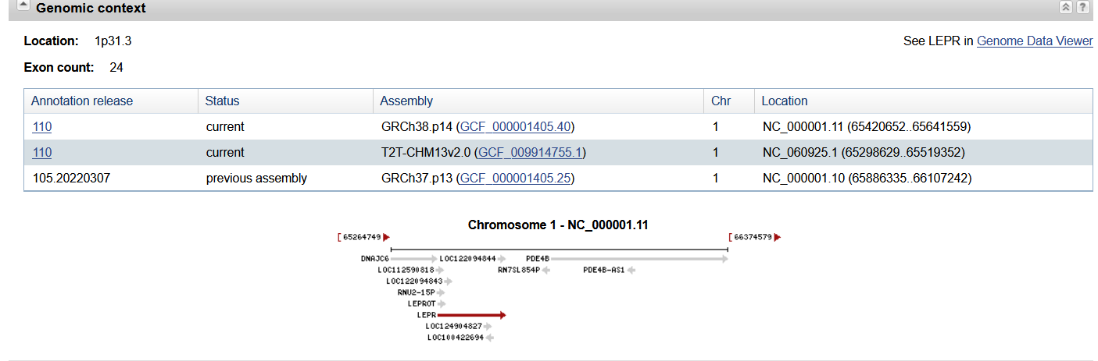

Genbank

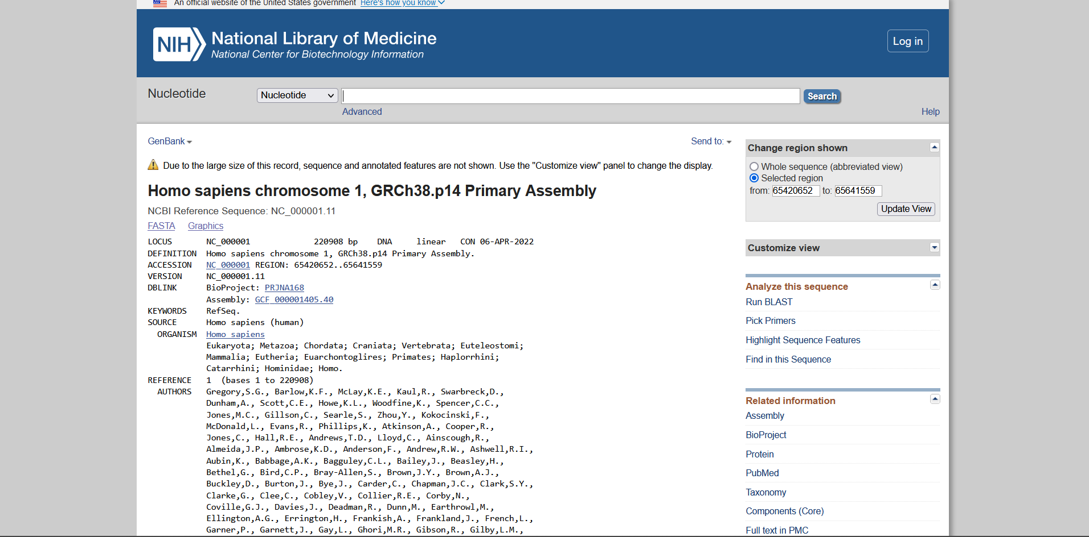

Gene Sequence – Leptin receptor Human

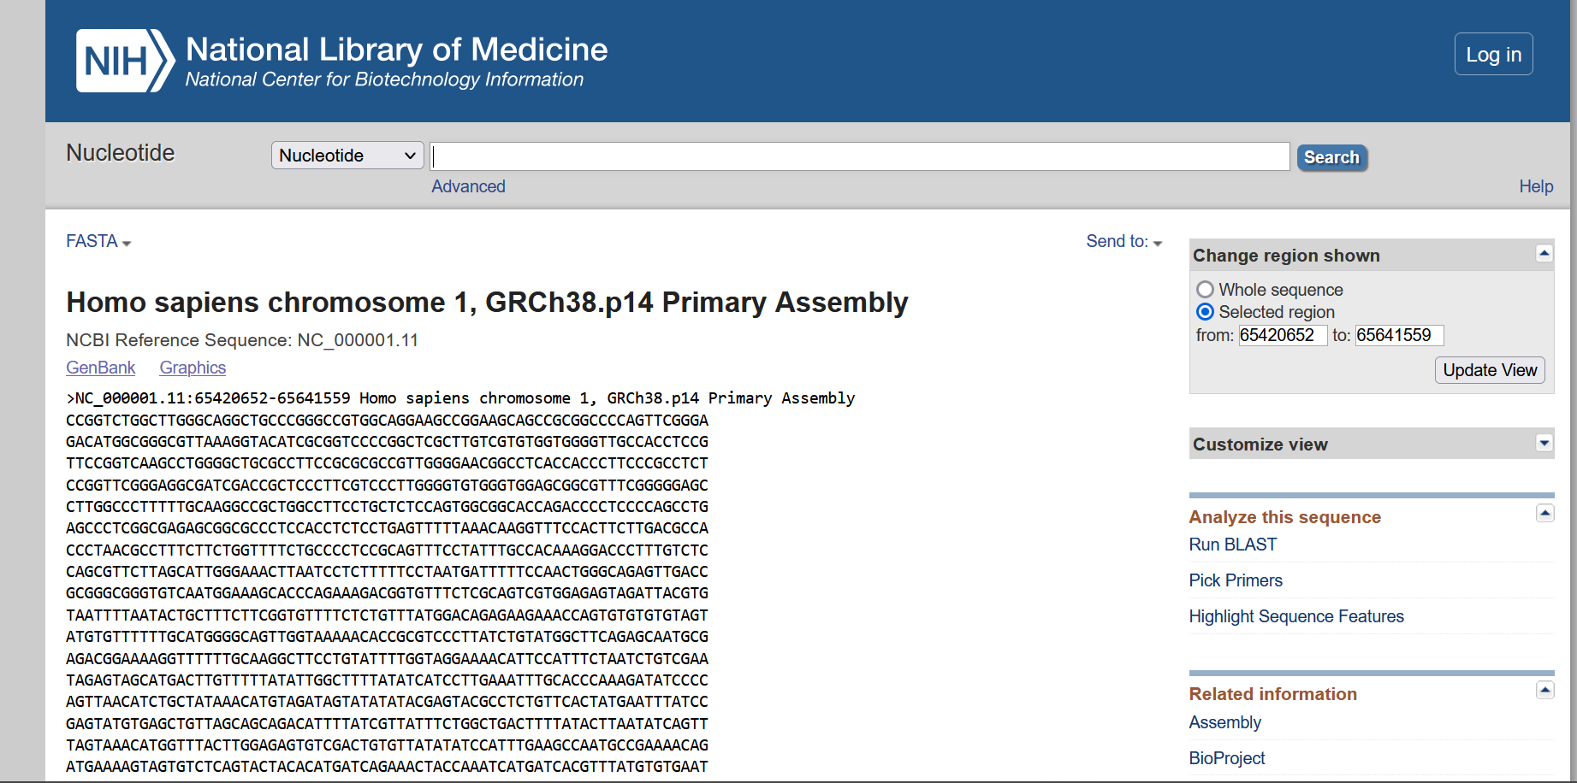

mRNA Sequence – Leptin receptor Human

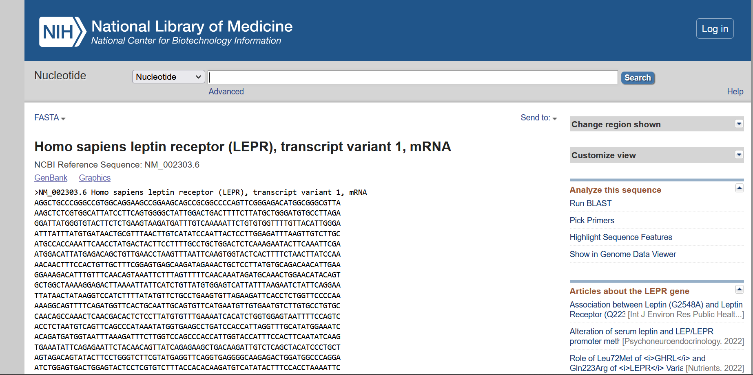

Organism: Mouse

|  |  |  |
| --- | --- | --- |
|  | Leptin | Leptin Receptor |
| Chromosomal Location | Chromosome 6  NC_000072.7 (29060220..29073875) | Chromosome 4  NC_000070.7 (101574393..101676375) |
| Length of Gene Sequence | 13656 bp | 101983 bp |
| Accession Number | NC_000072 | NC_000070 |
| Number of Exons | 3 | 21 |
| Start and End positions of Exons |  |  |
| Publications | REFERENCE - 1 (bases 1 to 13656)  AUTHORS - Church,D.M., Schneider,V.A., Graves,T., Auger,K., Cunningham,F.,  Bouk,N., Chen,H.C., Agarwala,R., McLaren,W.M., Ritchie,G.R., Albracht,D., Kremitzki,M., Rock,S., Kotkiewicz,H., Kremitzki,C.  TITLE - Modernizing reference genome assemblies  JOURNAL - PLoS Biol. 9 (7), e1001091 (2011)  PUBMED – 21750661 | REFERENCE - 1 (bases 1 to 101983)  AUTHORS - Church,D.M., Schneider,V.A., Graves,T., Auger,K., Cunningham,F.,Bouk,N., Chen,H.C., Agarwala,R., McLaren,W.M., Ritchie,G.R.,Albracht,D., Kremitzki,M., Rock,S., Kotkiewicz,H., Kremitzki,C.  TITLE - Modernizing reference genome assemblies  JOURNAL - PLoS Biol. 9 (7), e1001091 (2011)  PUBMED - 21750661 |

Hits page

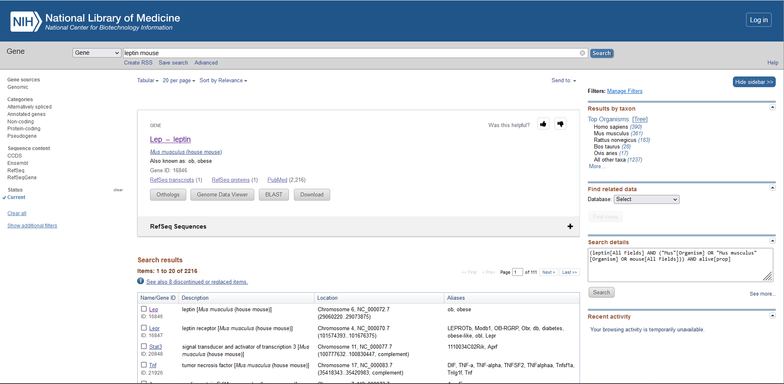

Chromosome location – Leptin Mouse

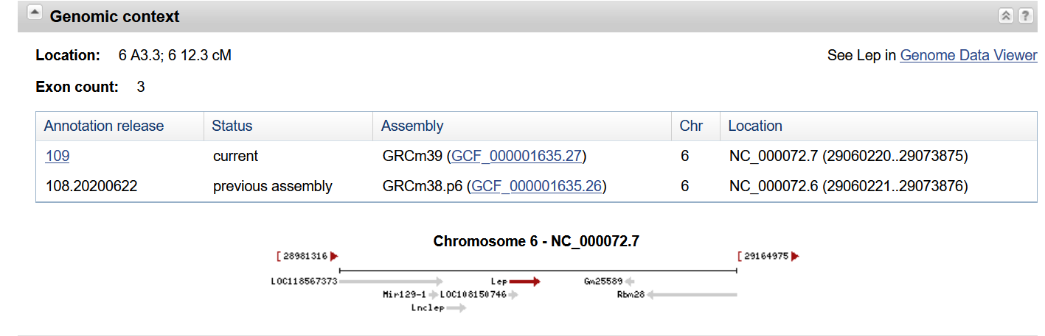

Genbank

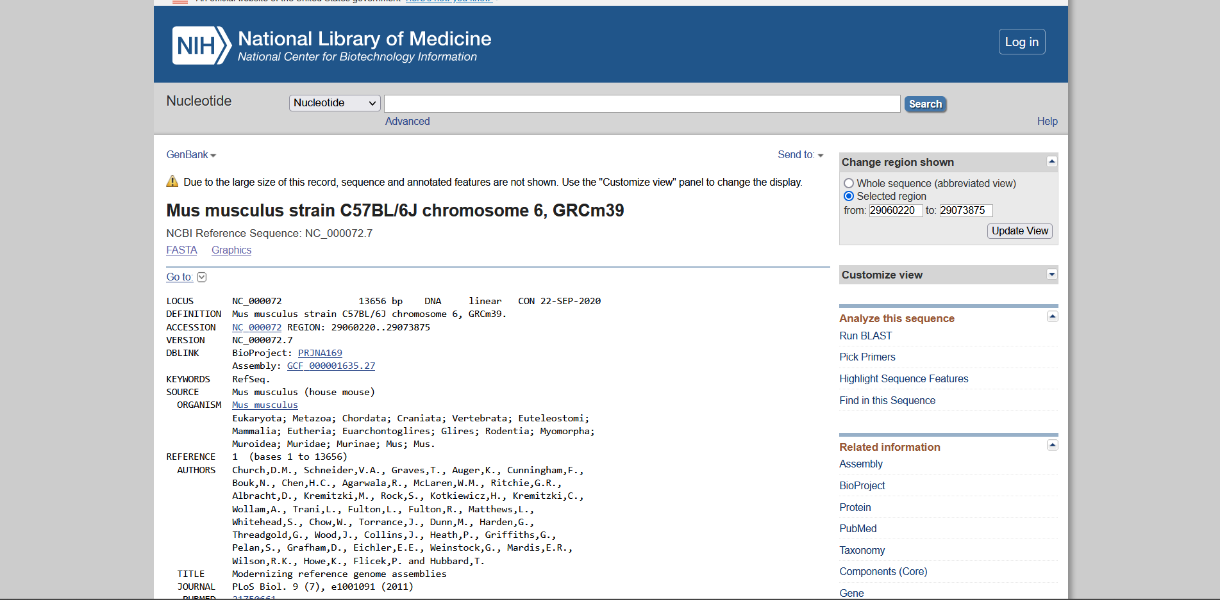

Gene Sequence – Leptin Mouse

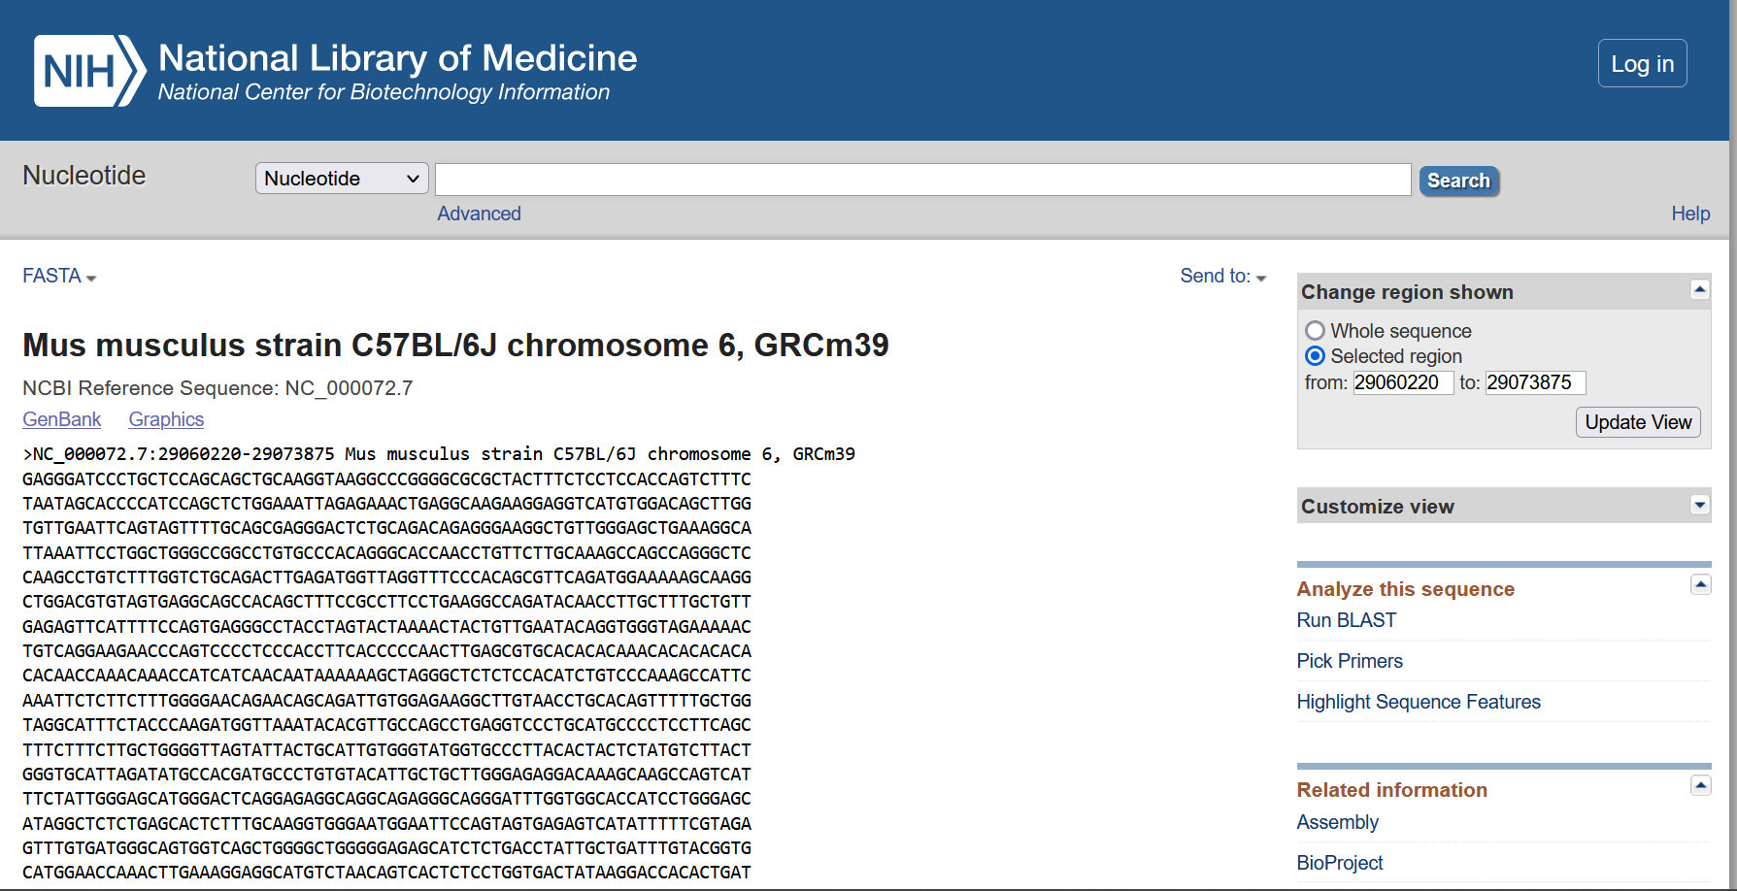

mRNA Sequence - Leptin Mouse

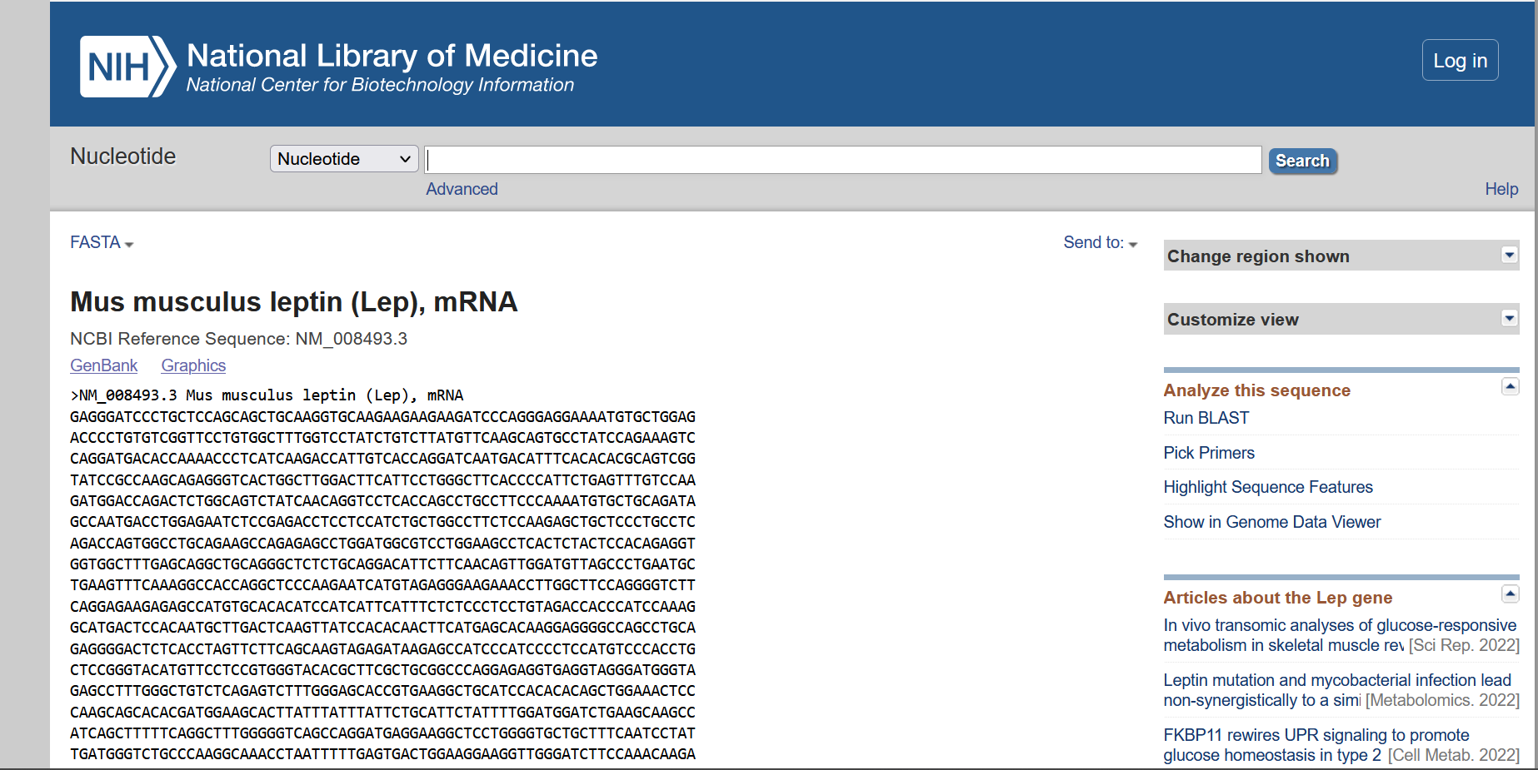

Chromosome location – Leptin receptor Mouse

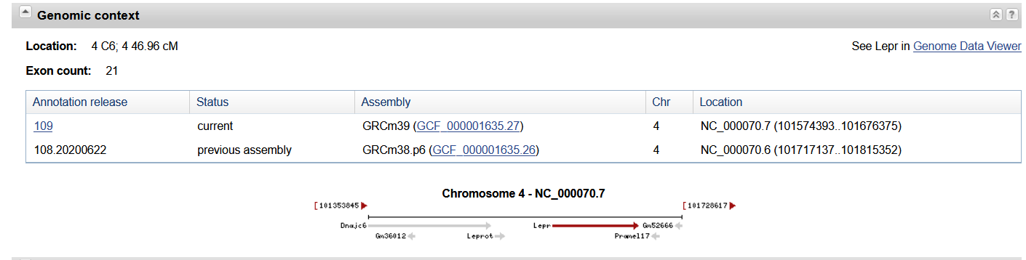

Genbank

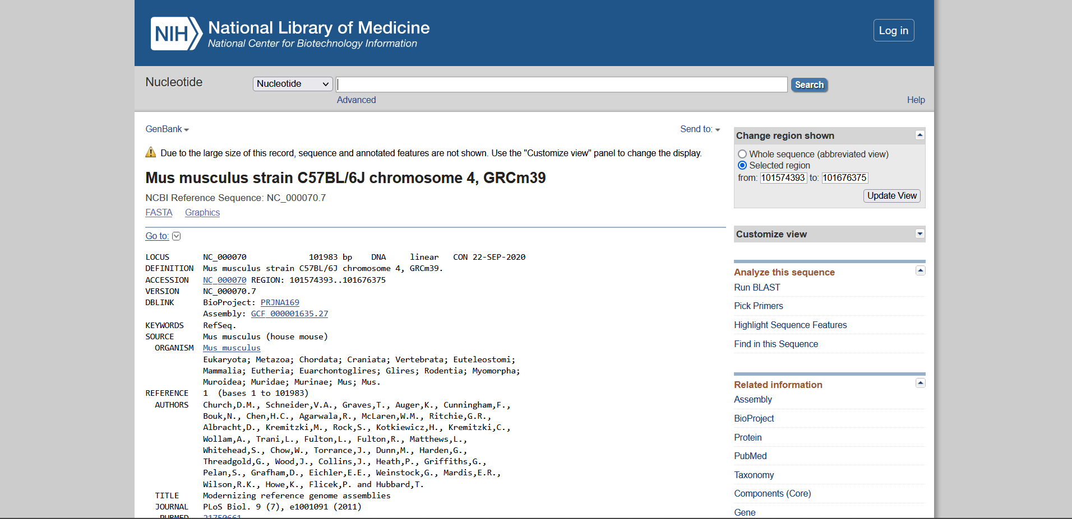

Gene Sequence – Leptin receptor Mouse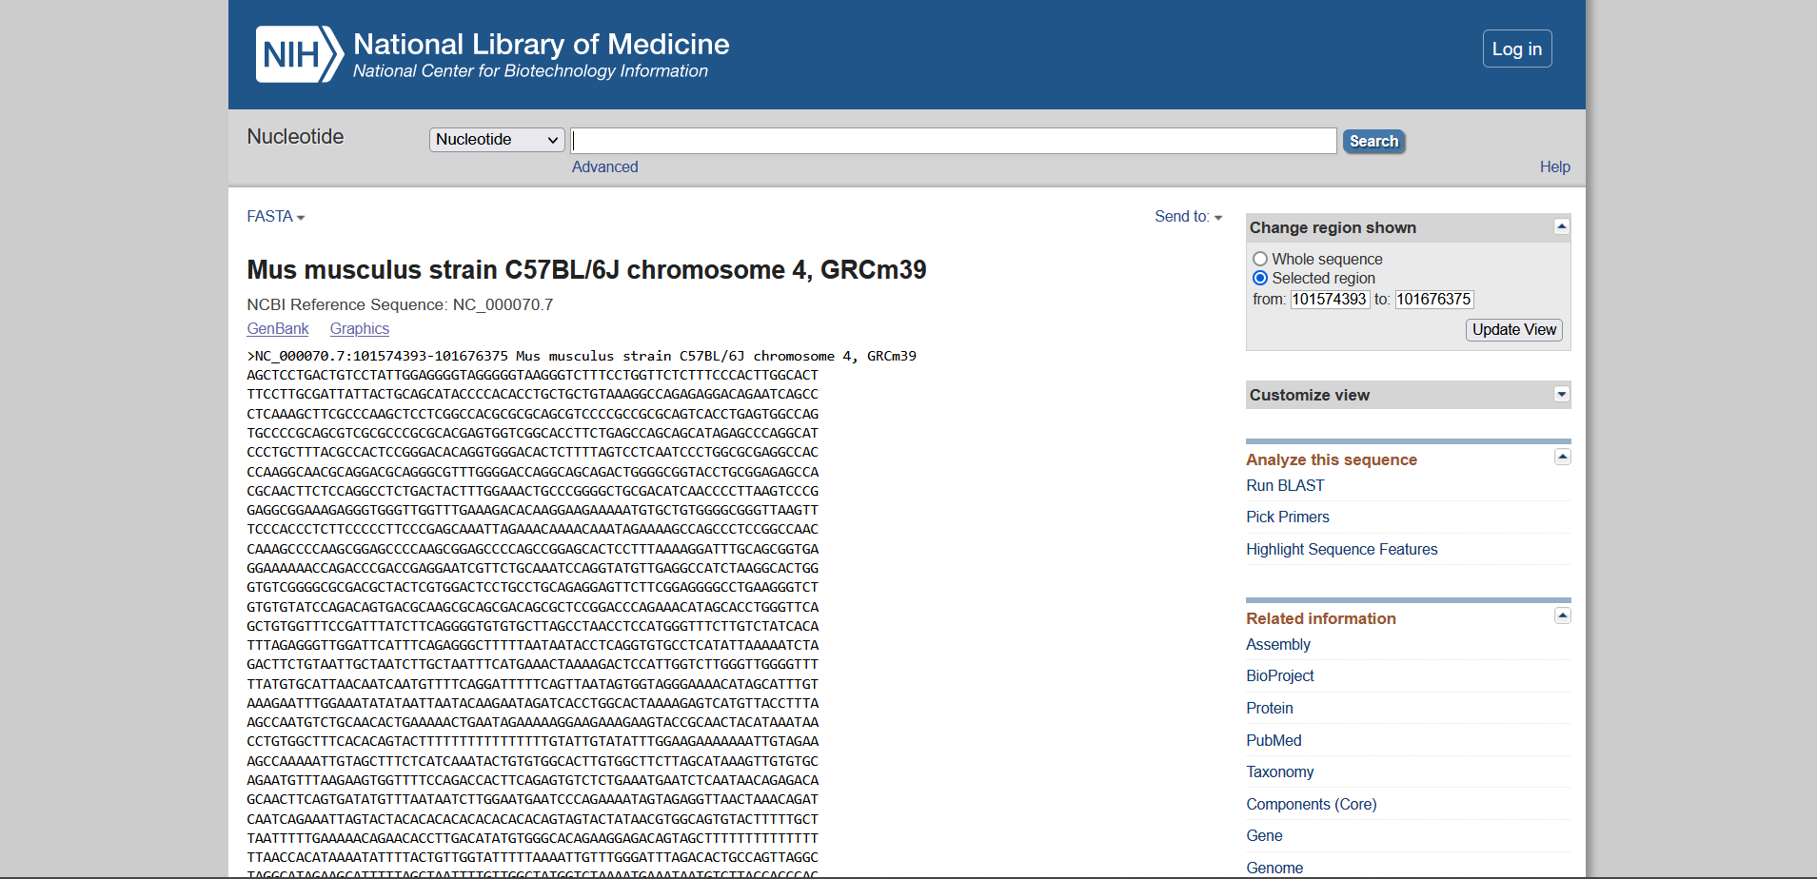

mRNA Sequence - Leptin receptor Mouse

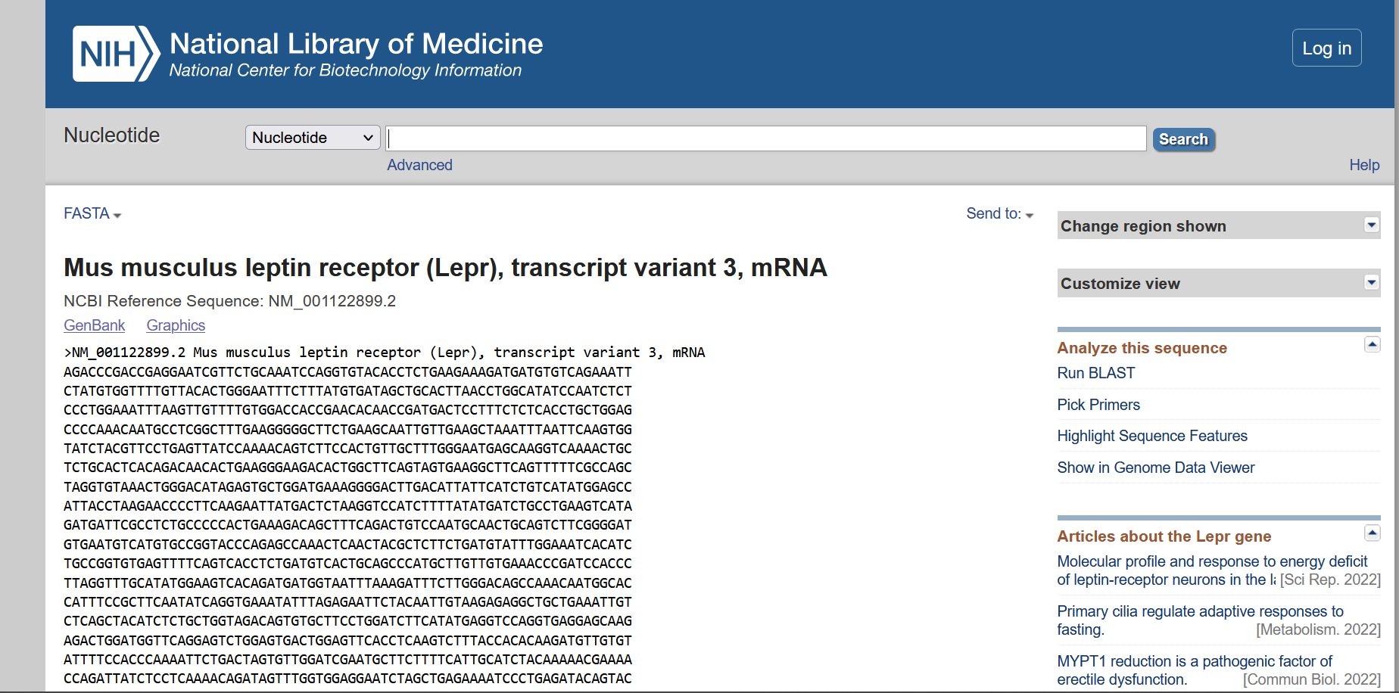

Organism: Rat

|  |  |  |
| --- | --- | --- |
|  | Leptin | Leptin Receptor |
| Chromosomal Location | Chromosome 4  NC_051339.1 (57661127..57675262) | Chromosome 5  NC_051340.1 (116294409..116477904) |
| Length of Gene Sequence | 14136 bp | 183496 bp |
| Accession Number | NC_051339 | NC_051340 |
| Number of Exons | 3 | 23 |
| Start and End positions of Exons |  |  |
| Publications |  |  |

Hits Page

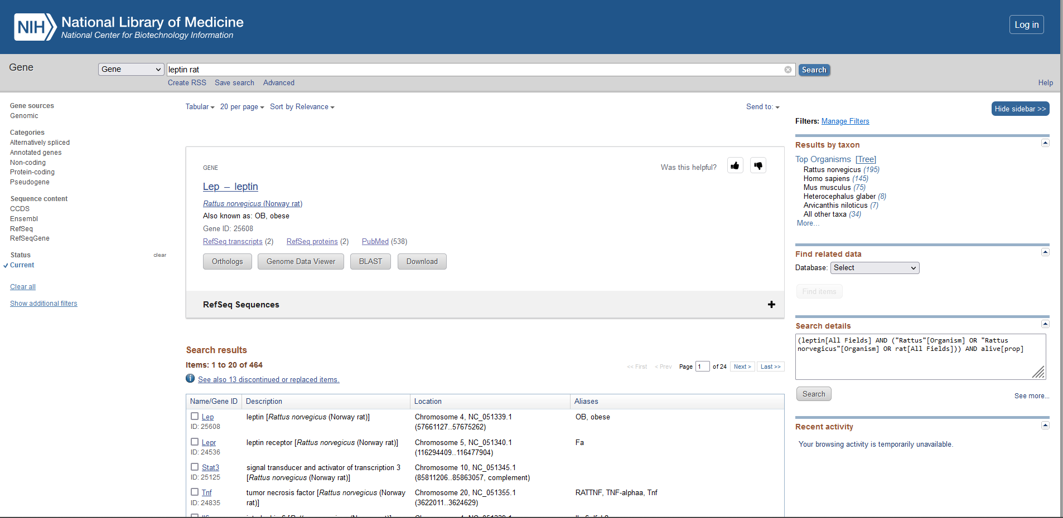

Chromosome location – Leptin Rat

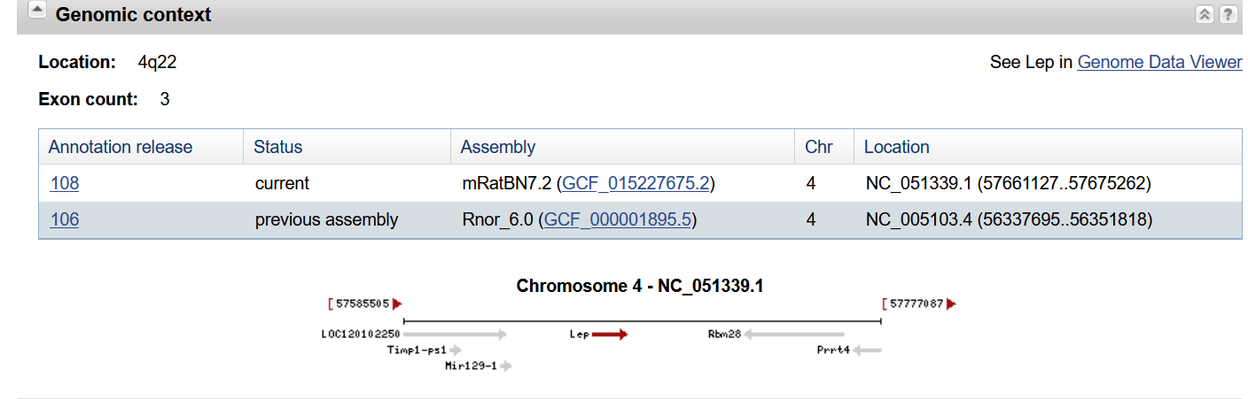

Genbank

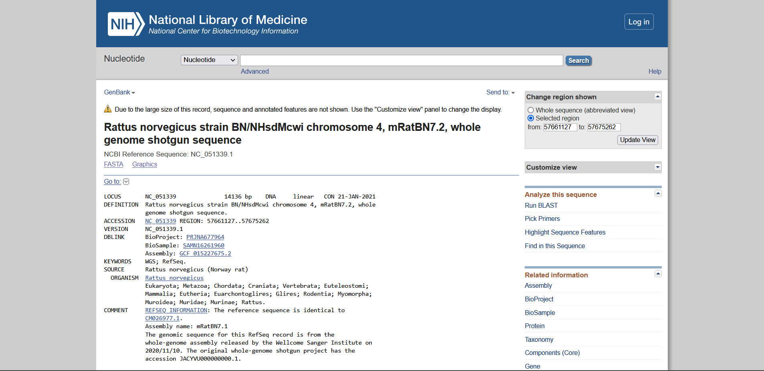

Gene Sequence – Leptin Rat

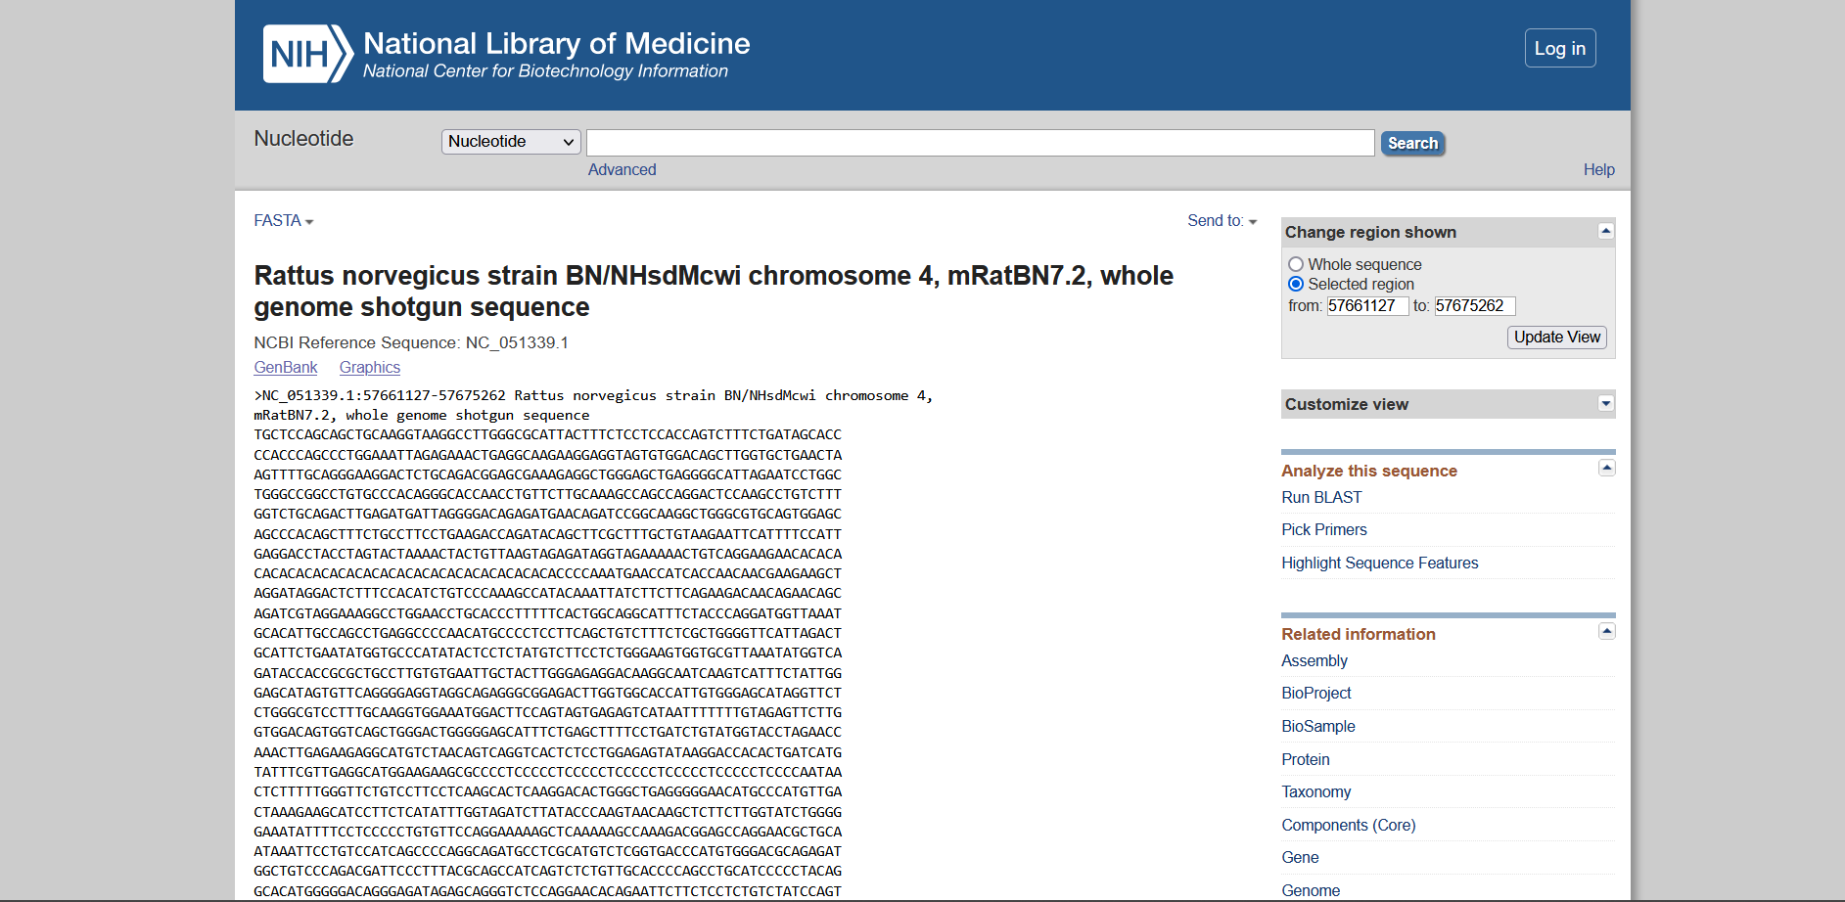

mRNA Sequence - Leptin Rat

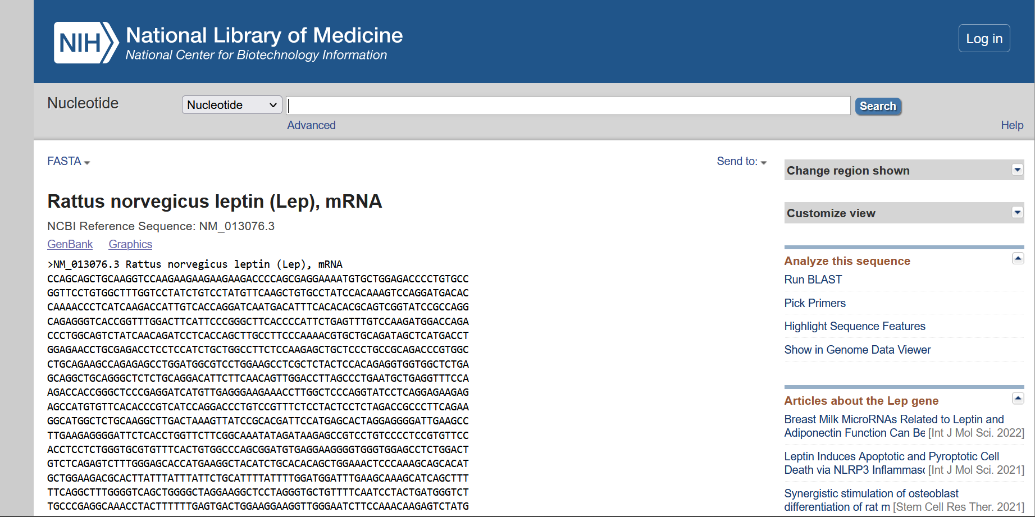

Chromosome location – Leptin receptor Rat

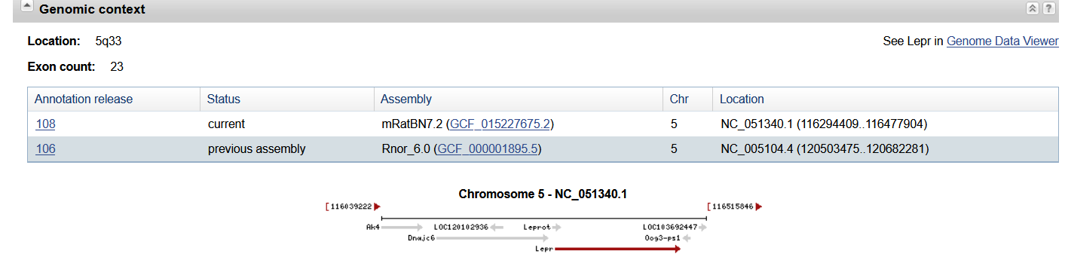

Genbank

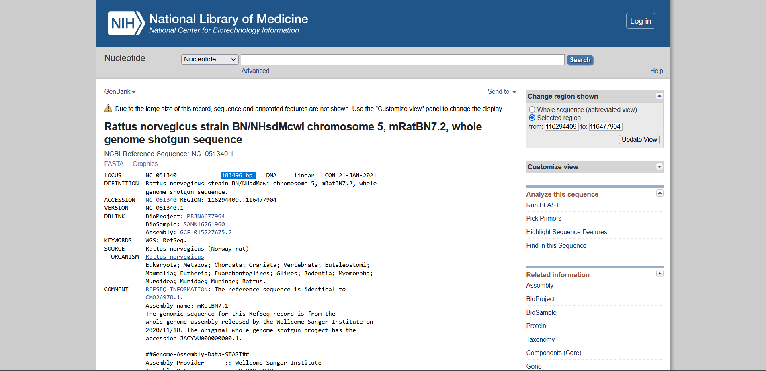

Gene Sequence – Leptin receptor Rat

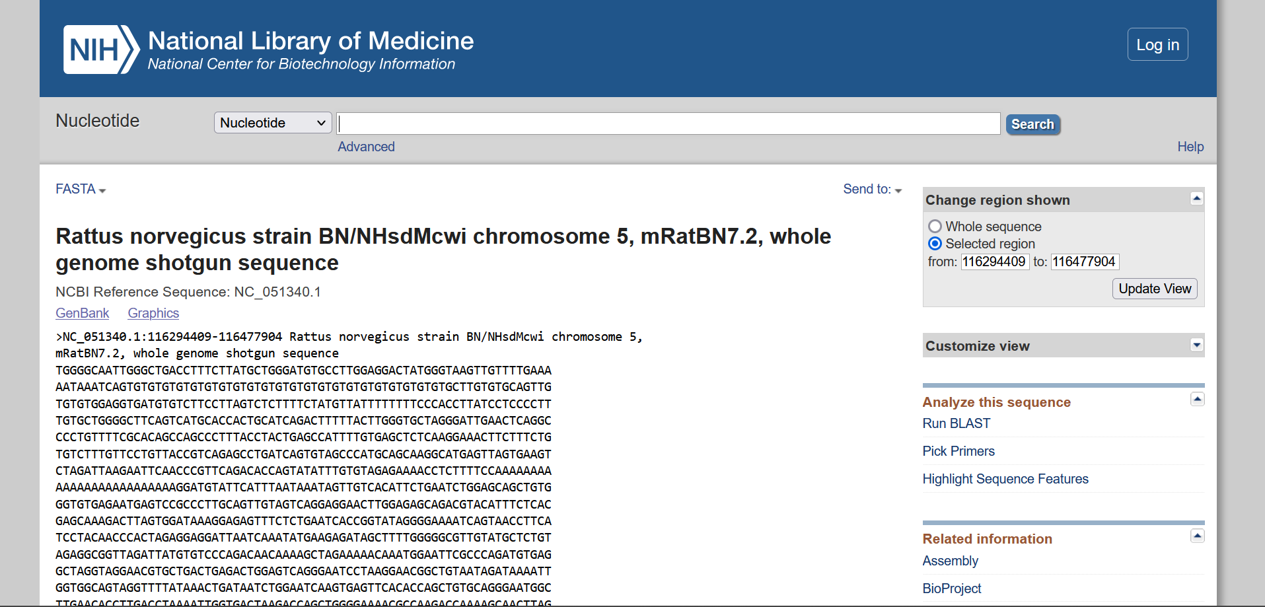

mRNA Sequence - Leptin receptor Rat

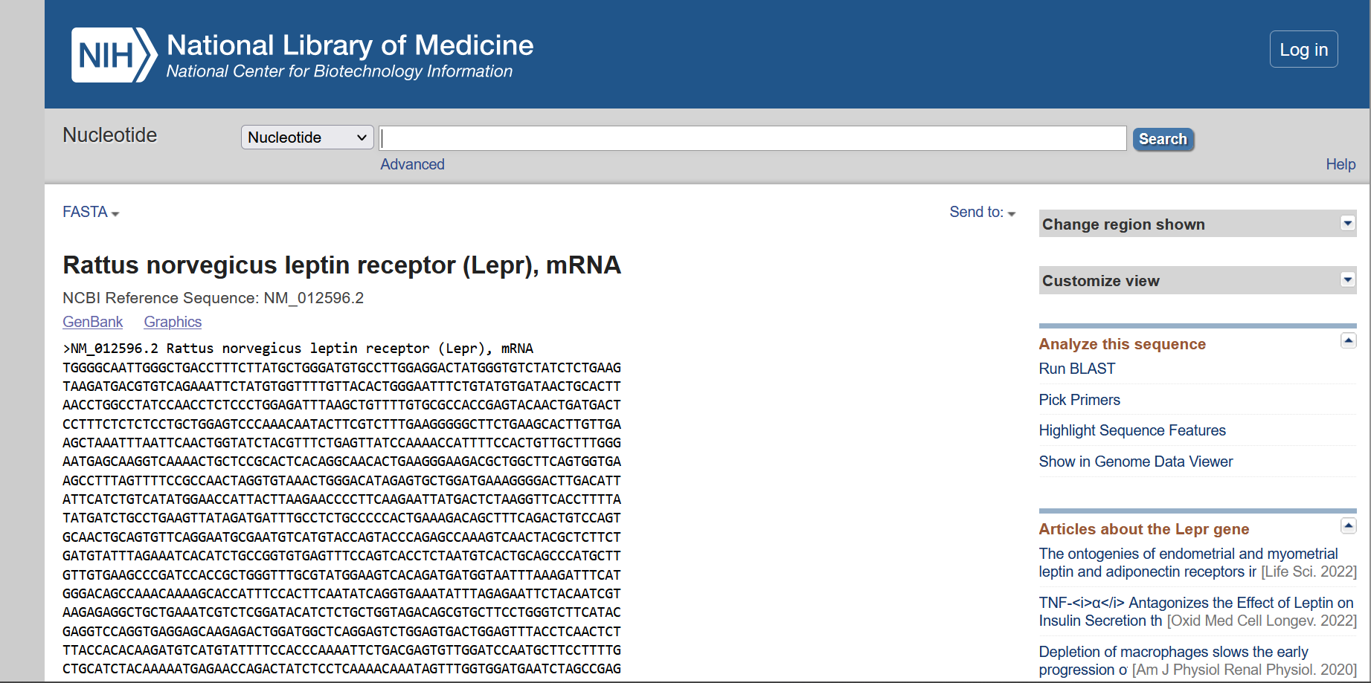

Organism: Cattle

|  |  |  |
| --- | --- | --- |
|  | Leptin | Leptin Receptor |
| Chromosomal Location | Chromosome 4  NC_037331.1 (92436837..92453660) | Chromosome 3  NC_037330.1 (79741204..79838014, complement) |
| Length of Gene Sequence | 16824 bp | 96811 bp |
| Accession Number | NC_037331 | NC_037330 |
| Number of Exons | 3 | 21 |
| Start and End positions of Exons |  |  |
| Publications |  |  |

Hits Page

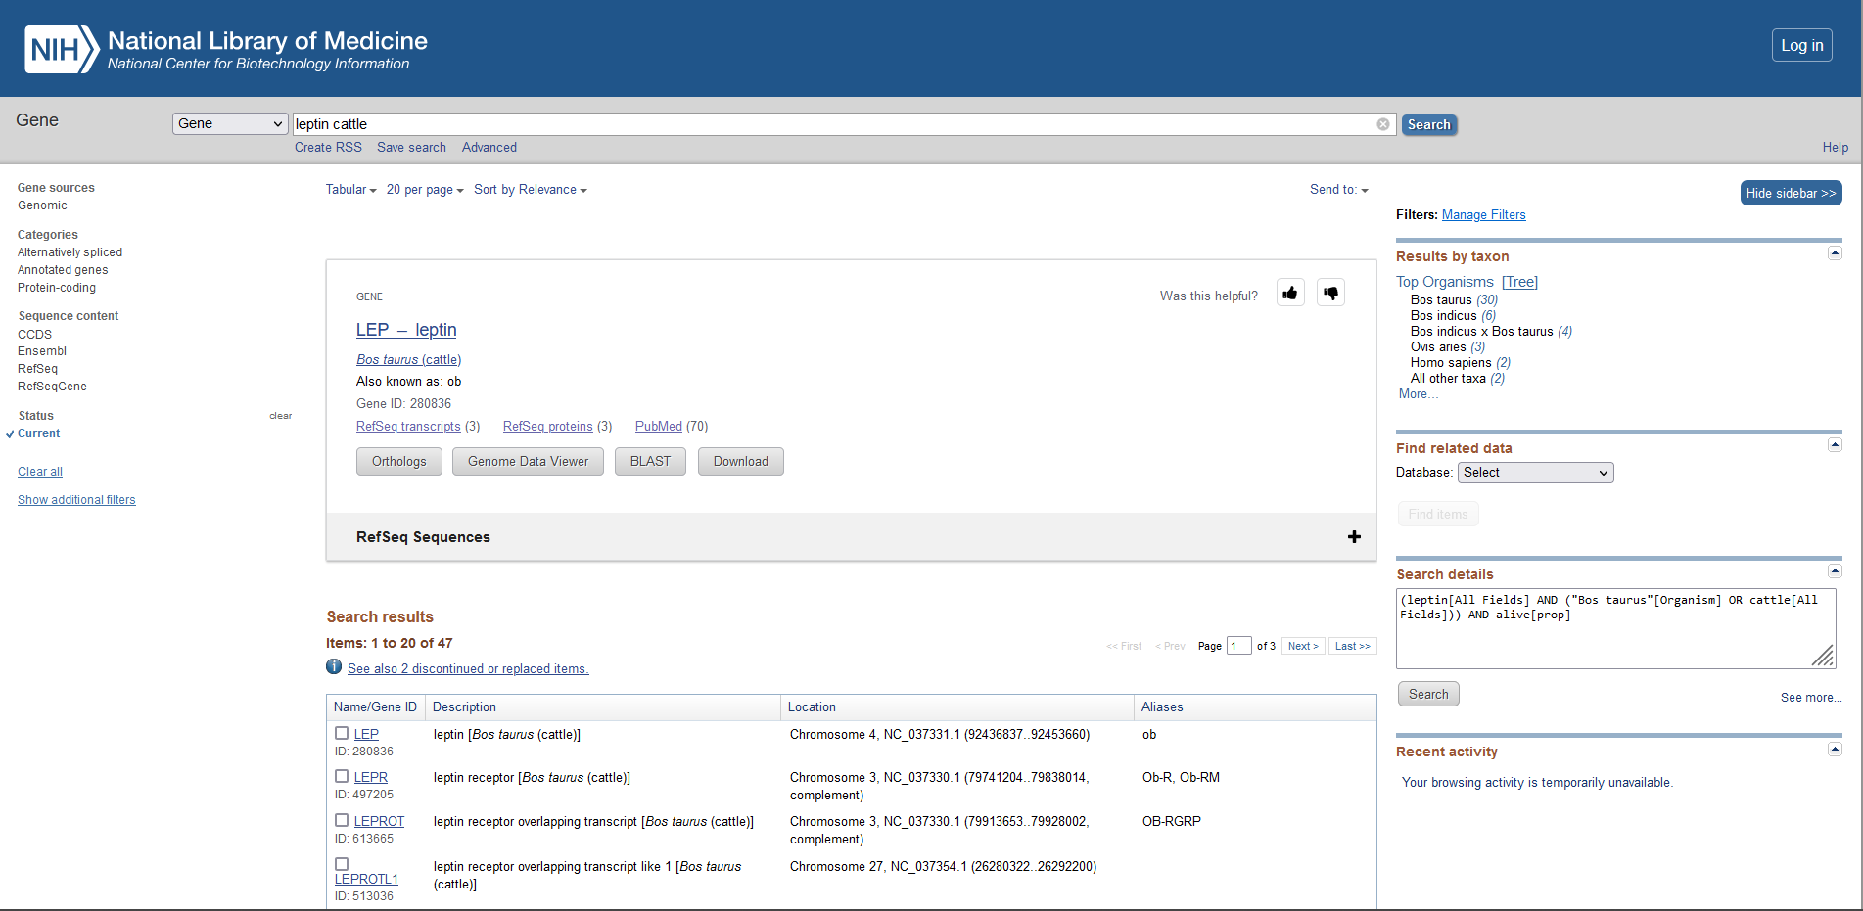

Chromosome location – Leptin cattle

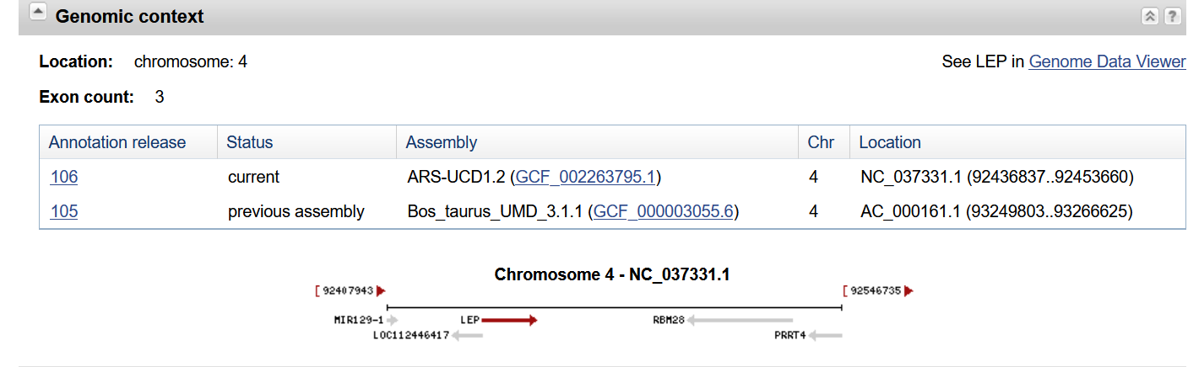

Genbank

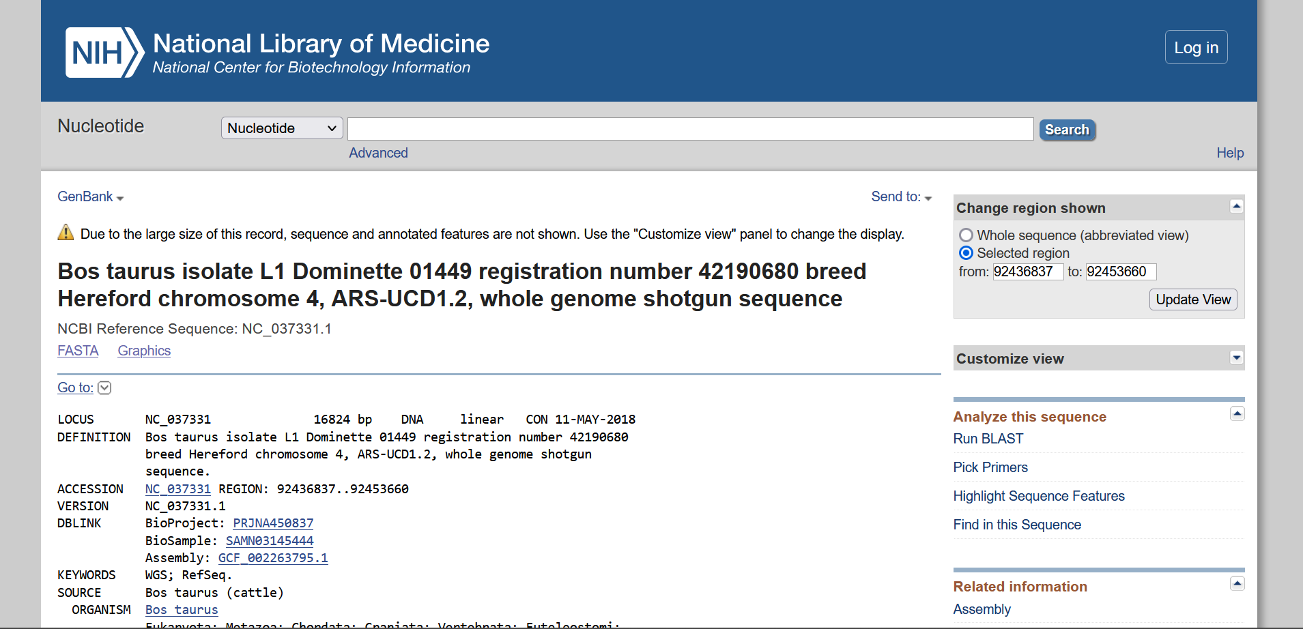

Gene Sequence – Leptin cattle

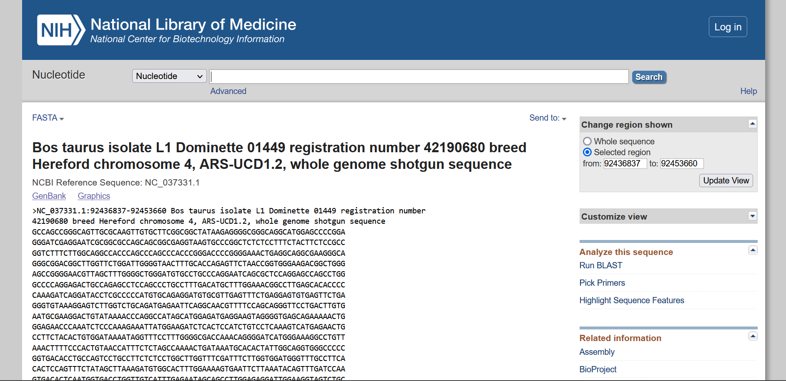

mRNA Sequence - Leptin cattle

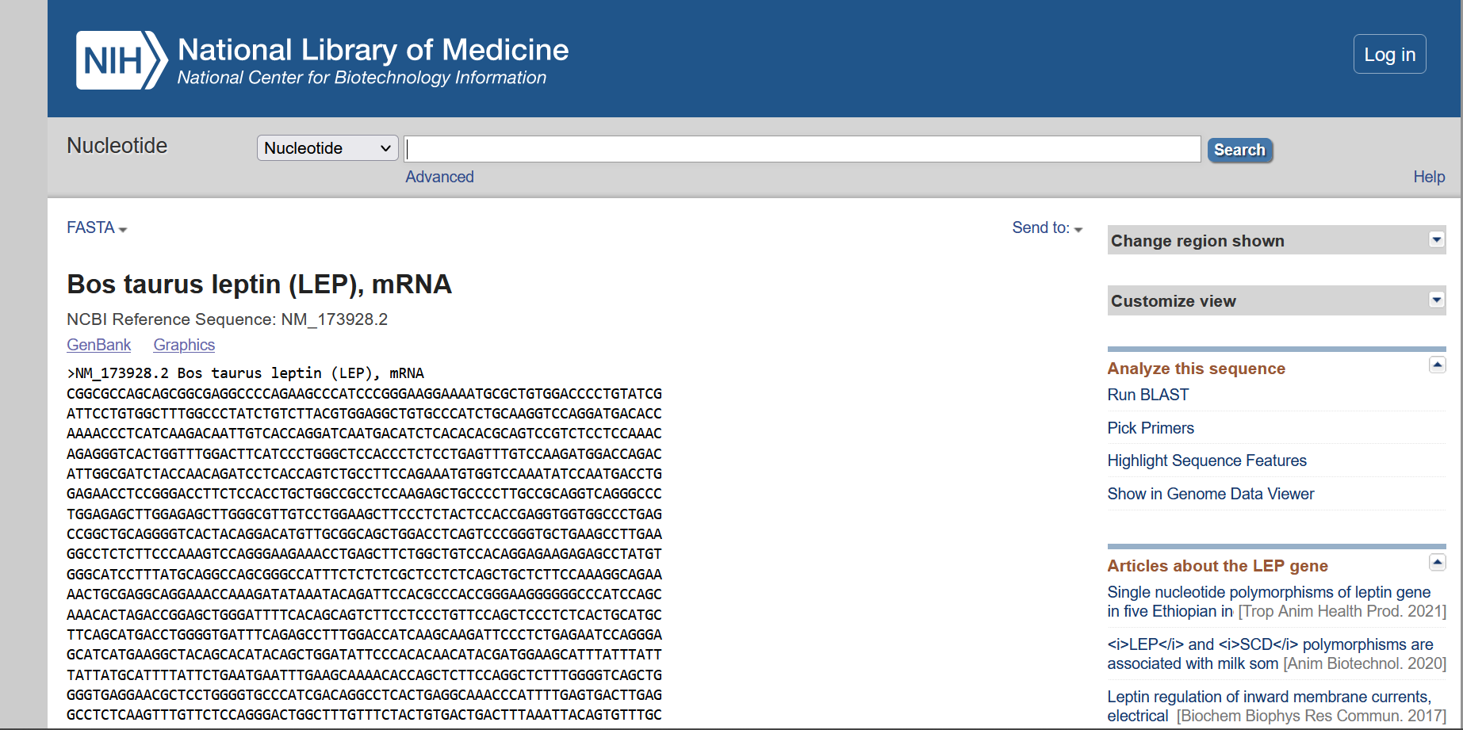

Chromosome location – Leptin receptor cattle

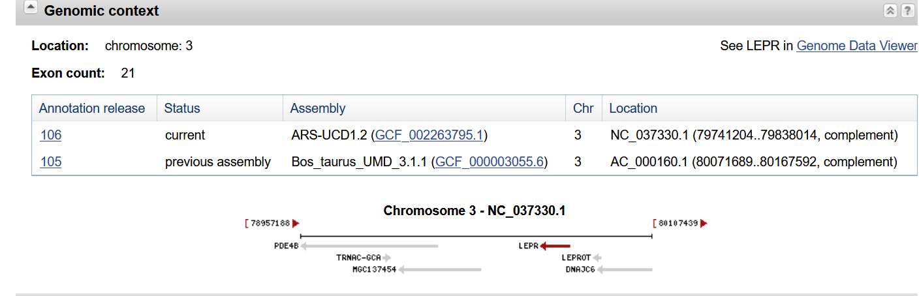

Genbank

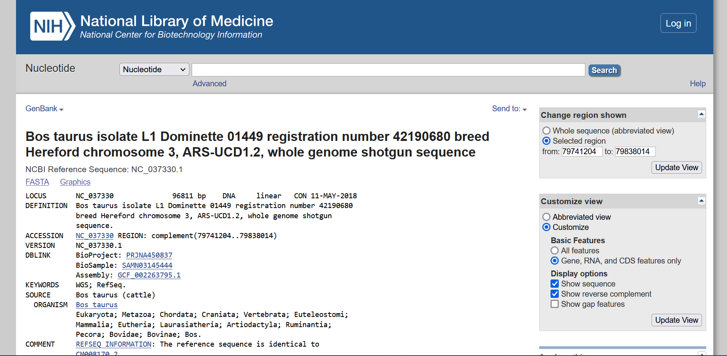

Gene Sequence – Leptin receptor cattle

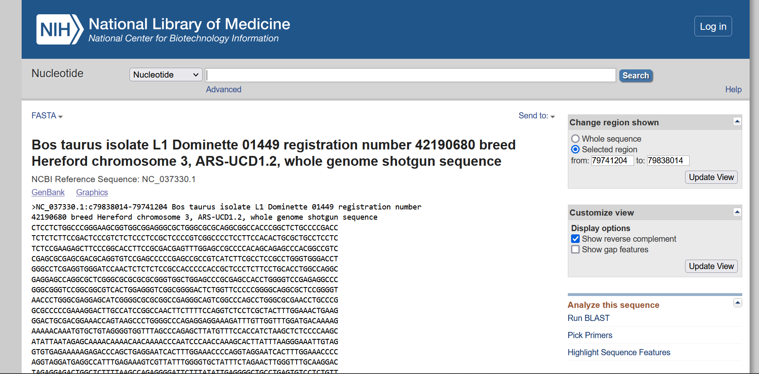

mRNA Sequence - Leptin receptor cattle

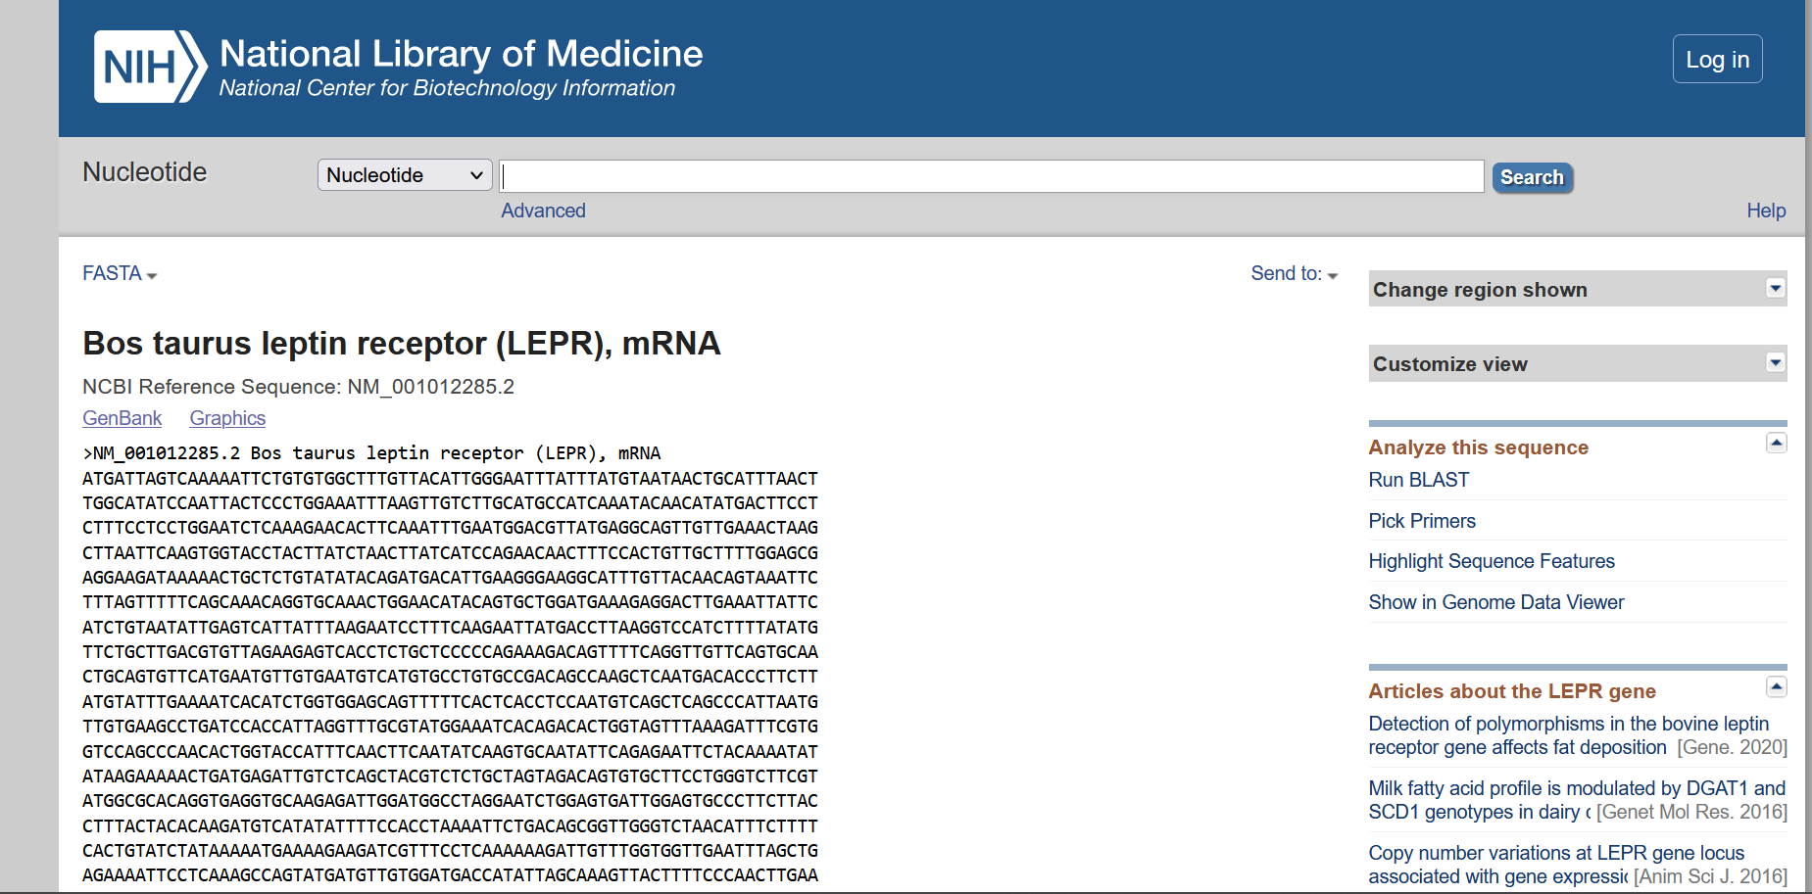

Organism: Pig

|  |  |  |
| --- | --- | --- |
|  | Leptin | Leptin Receptor |
| Chromosomal Location | Chromosome 18  NC_010460.4 (20106867..20124071, complement) | Chromosome 6  NC_010448.4 (146802297..146896152, complement) |
| Length of Gene Sequence | 17205 bp | 93856 bp |
| Accession Number | NC_010460 | NC_010448 |
| Number of Exons | 5 | 22 |
| Start and End positions of Exons |  |  |
| Publications |  |  |

Hits Page

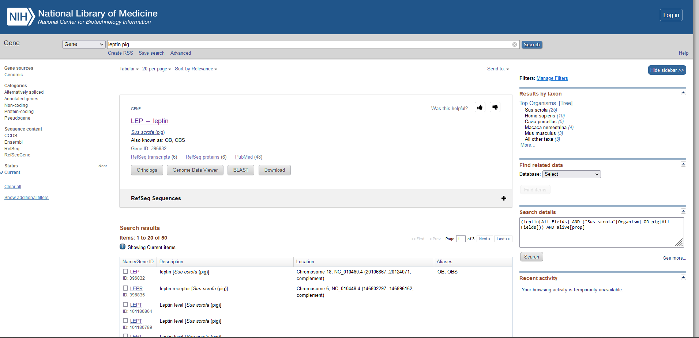

Chromosome location – Leptin Pig

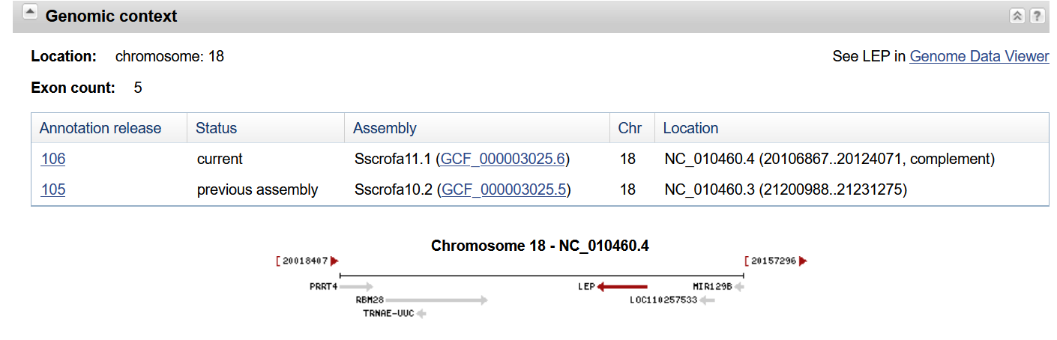

Genbank

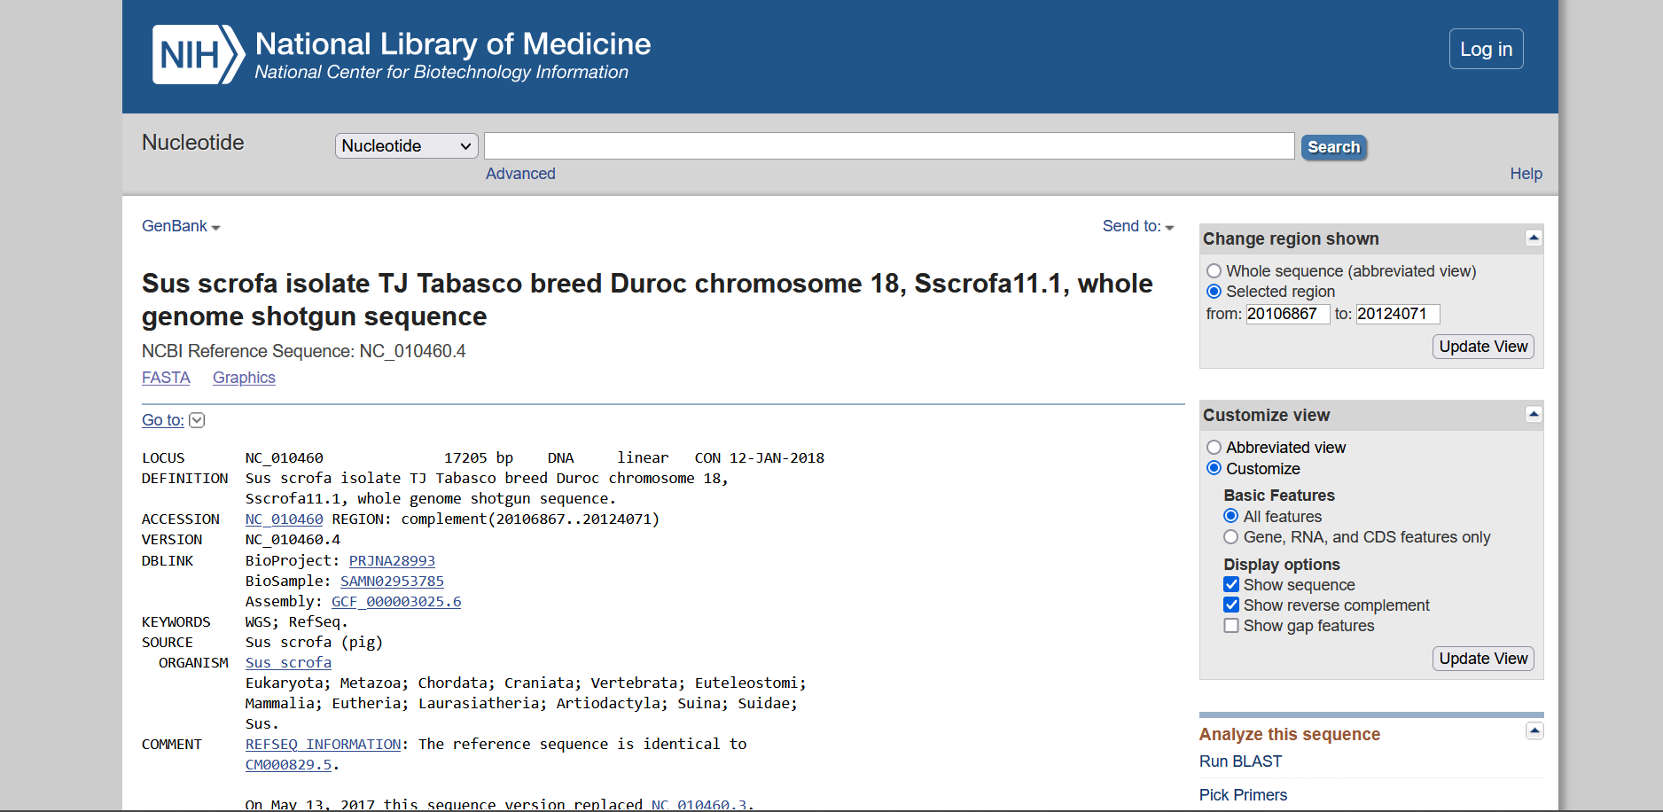

Gene Sequence – Leptin Pig

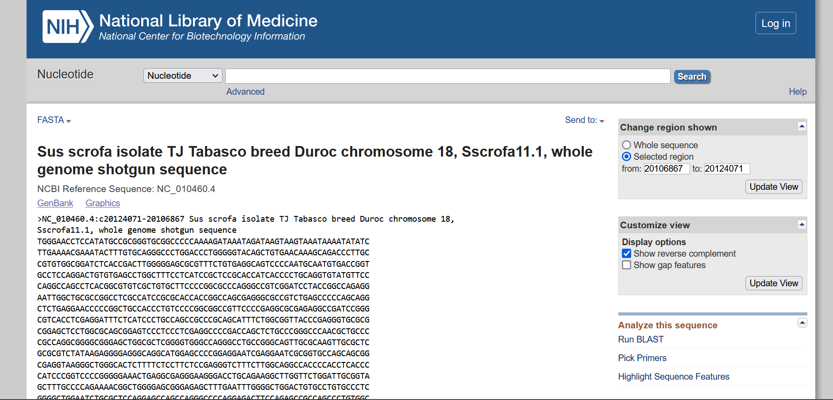

mRNA Sequence - Leptin Pig

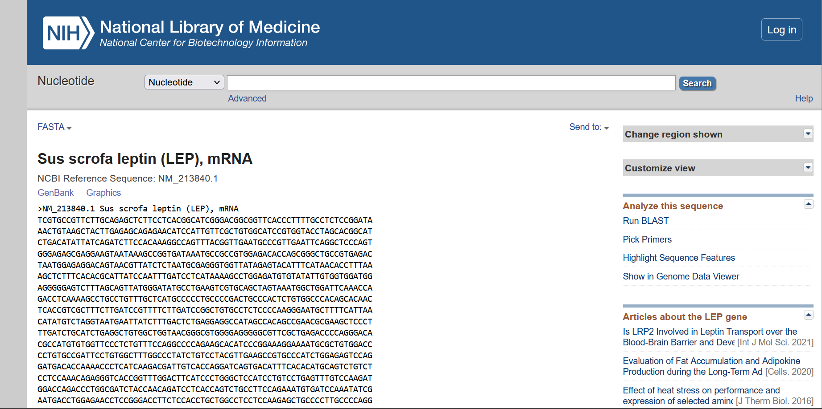

Chromosome location – Leptin receptor Pig

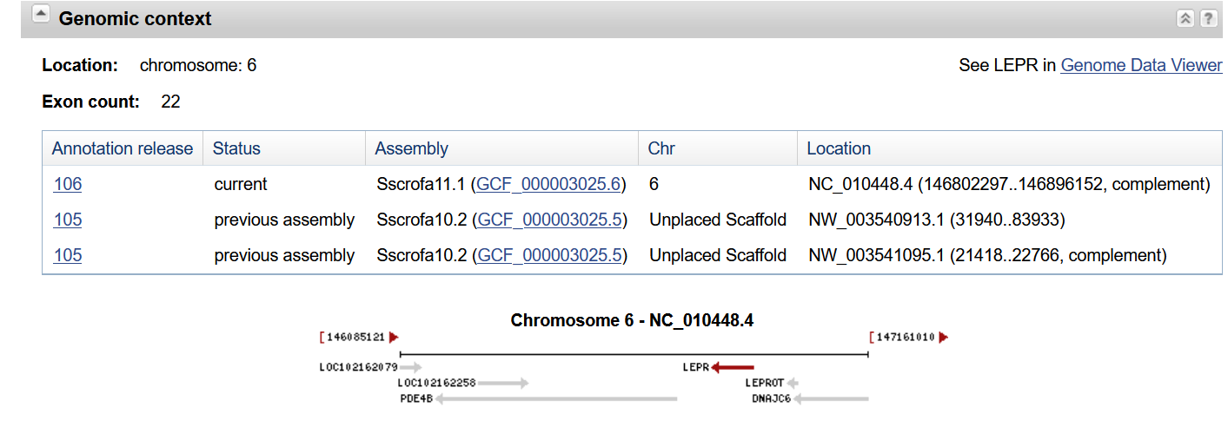

Genbank

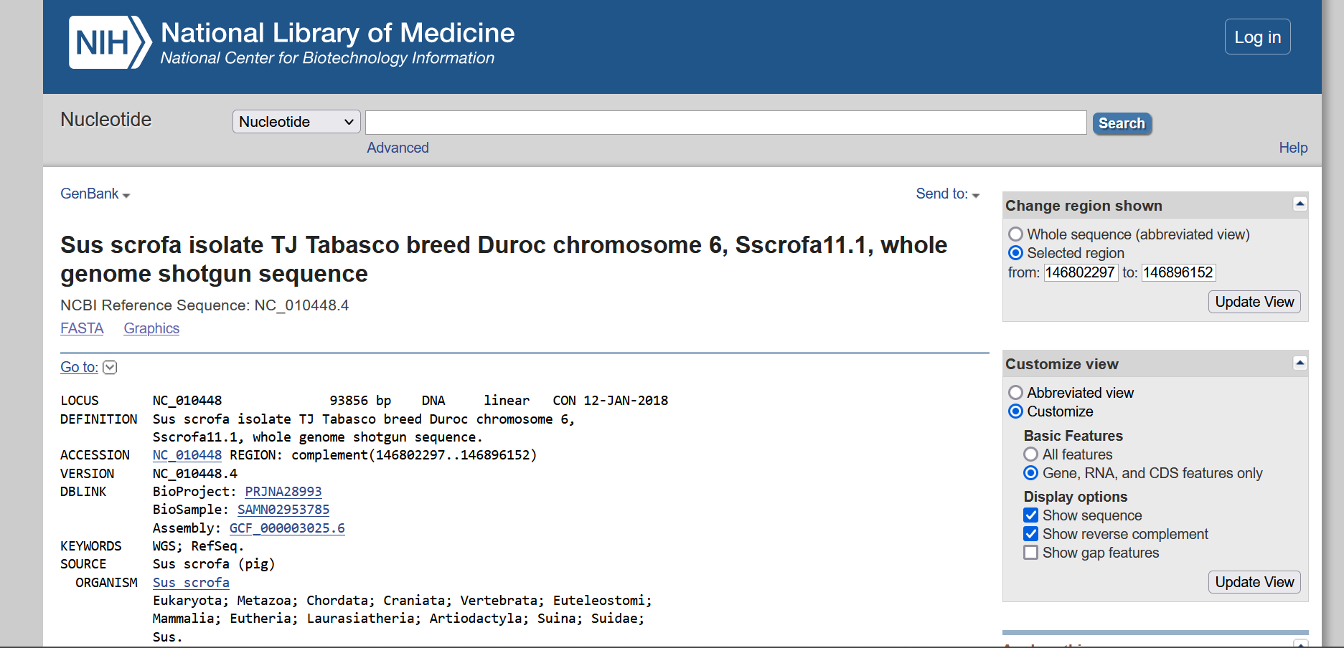

Gene Sequence – Leptin receptor Pig

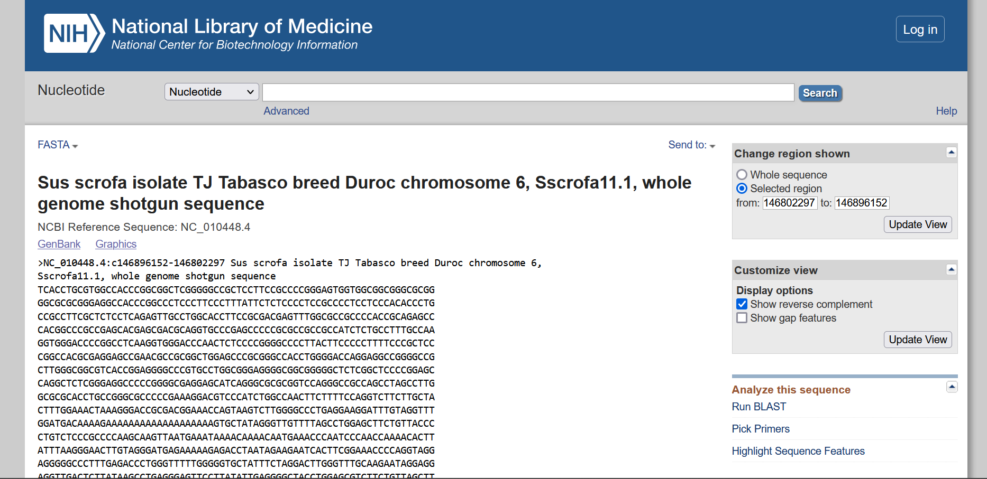

mRNA Sequence - Leptin receptor Pig

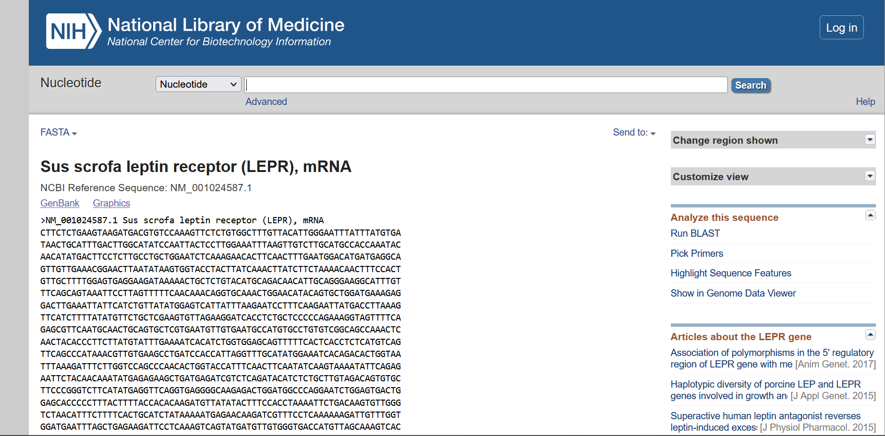

I) Retrieve the information of beta globin chain of Haemoglobin using the Uniprot ID P69892

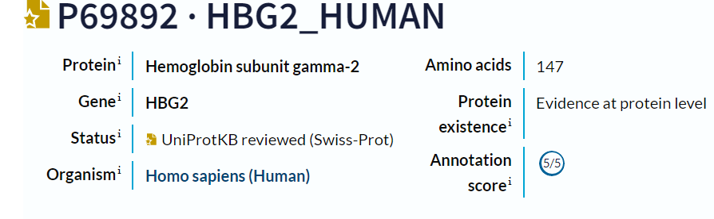

1. Write down the contents of feature table

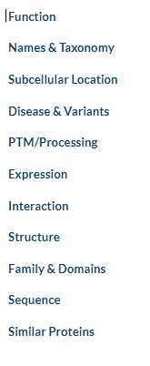

Contents of the feature table are Function, Names &Taxonomy, Subcellular Location, Disease & Variants, PTM/Processing, Expression, Interaction, Structure, Family&Domains, Sequence and Similar Proteins

1. What are the molecular and biological function of the protein? Cite with one reference.

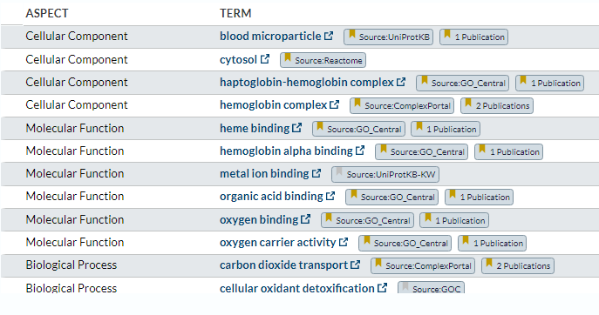

Publications

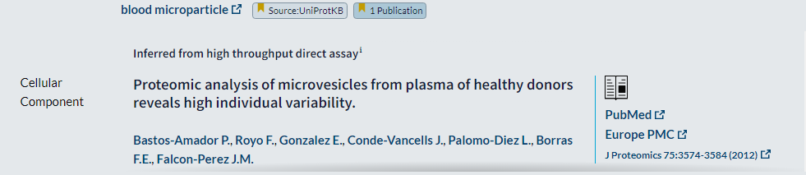

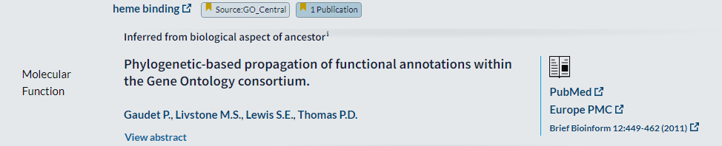

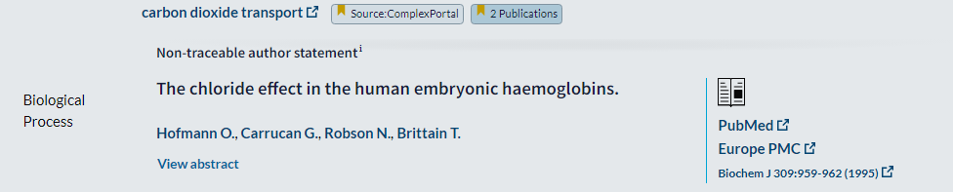

3.What are the amino acid modification of these proteins?

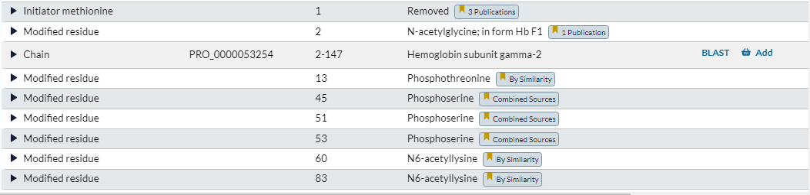

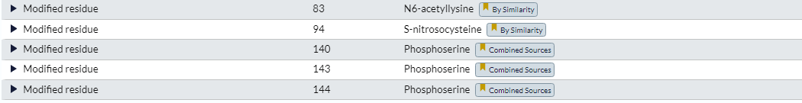

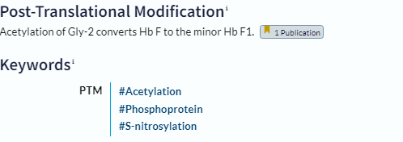

4. How many binary interactions of these proteins are found?

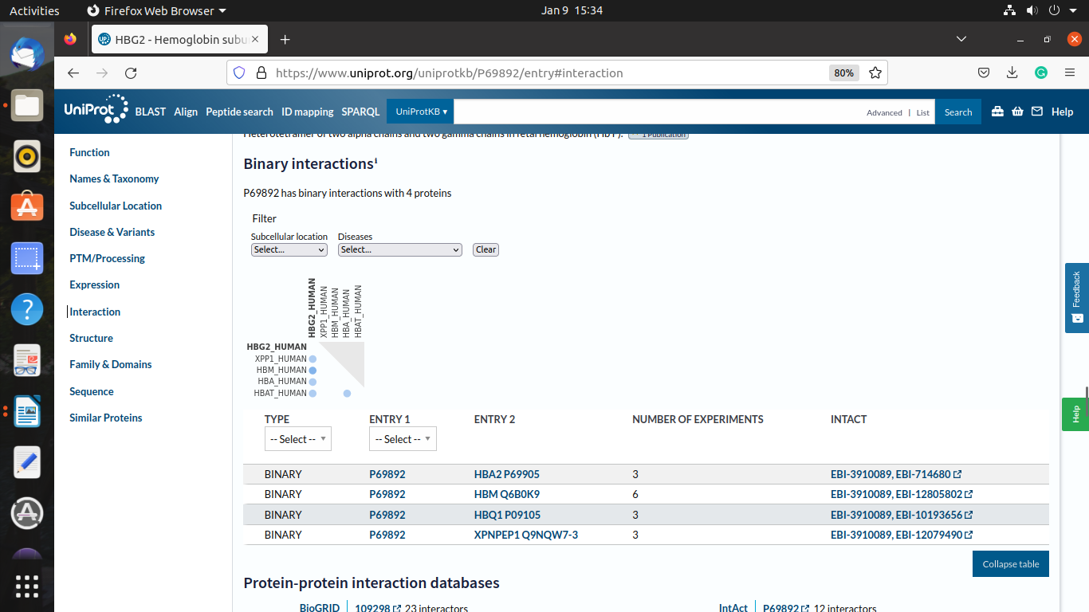

5. How many protein structures are found and their PDB ID?

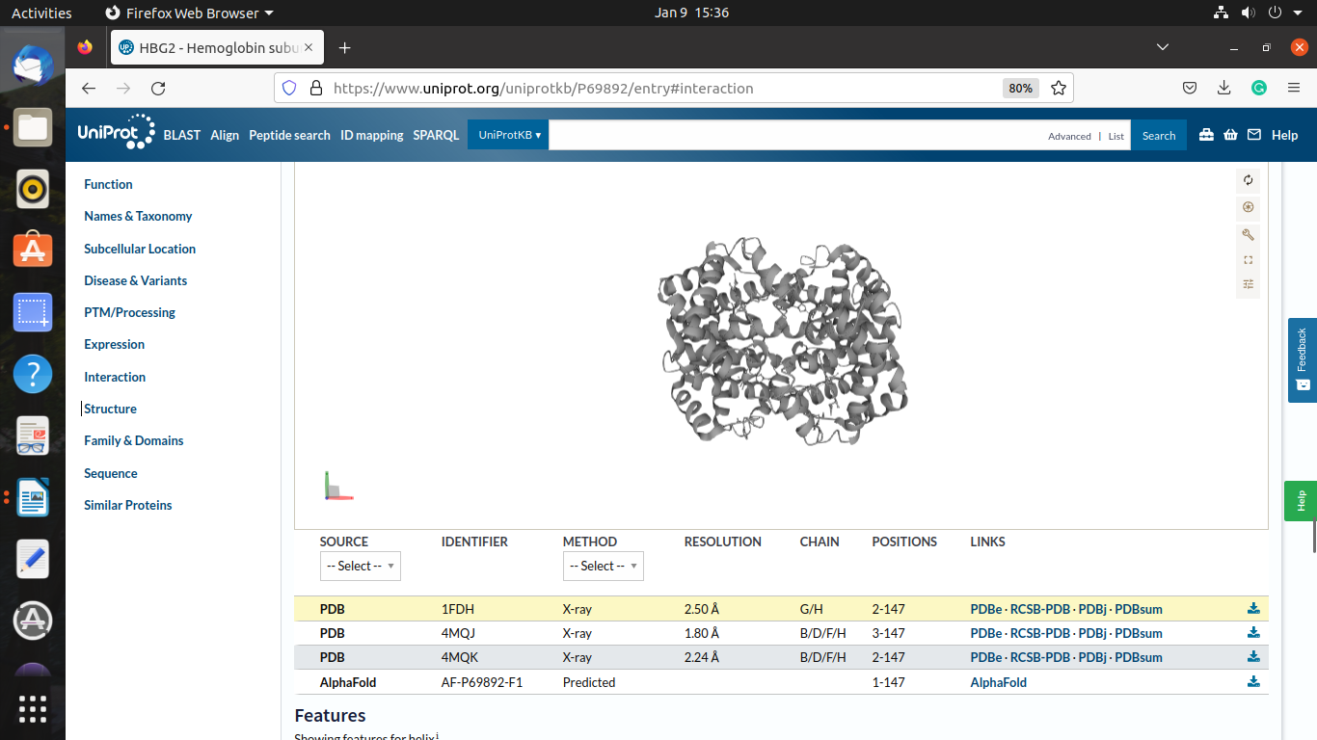

6. How many isoforms of protein are there?

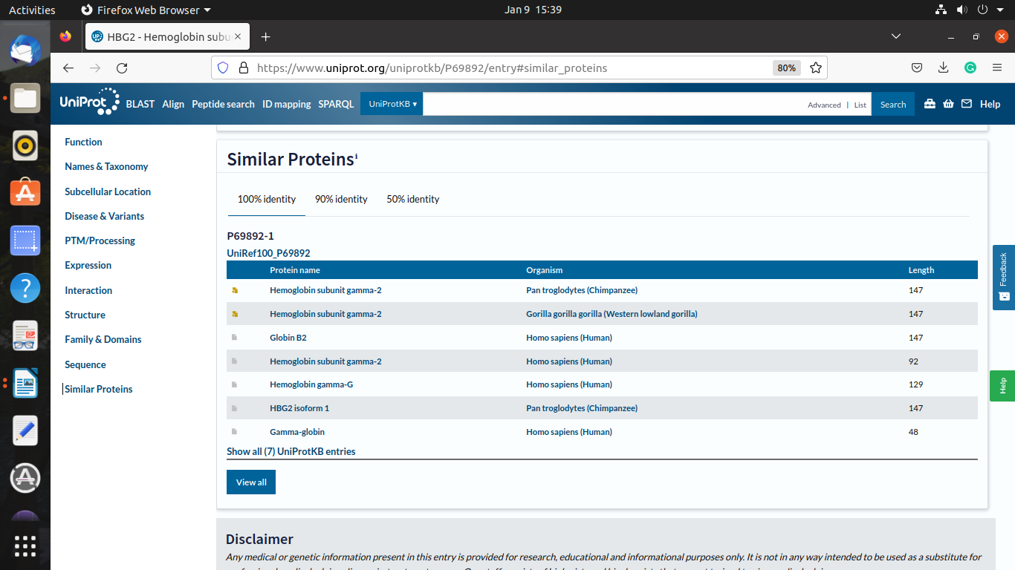

7. What is the length of the amino acid composition?

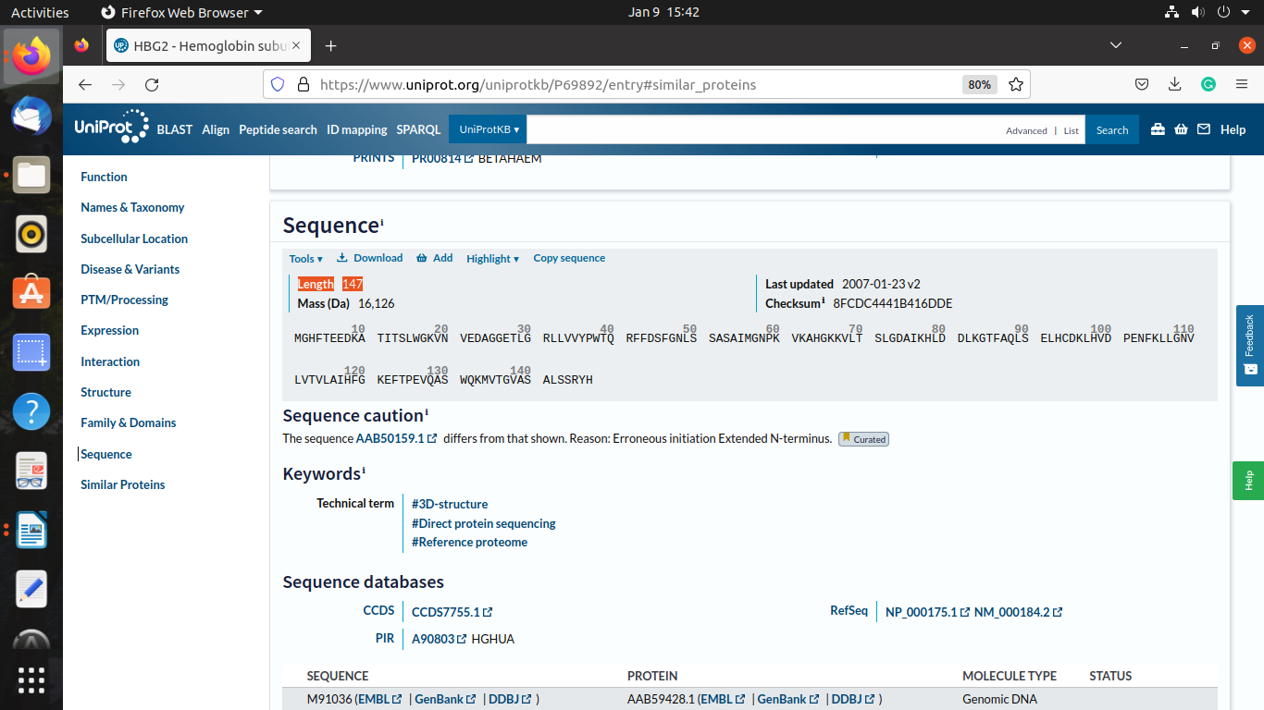

8. What are the structural differences of these proteins with references?

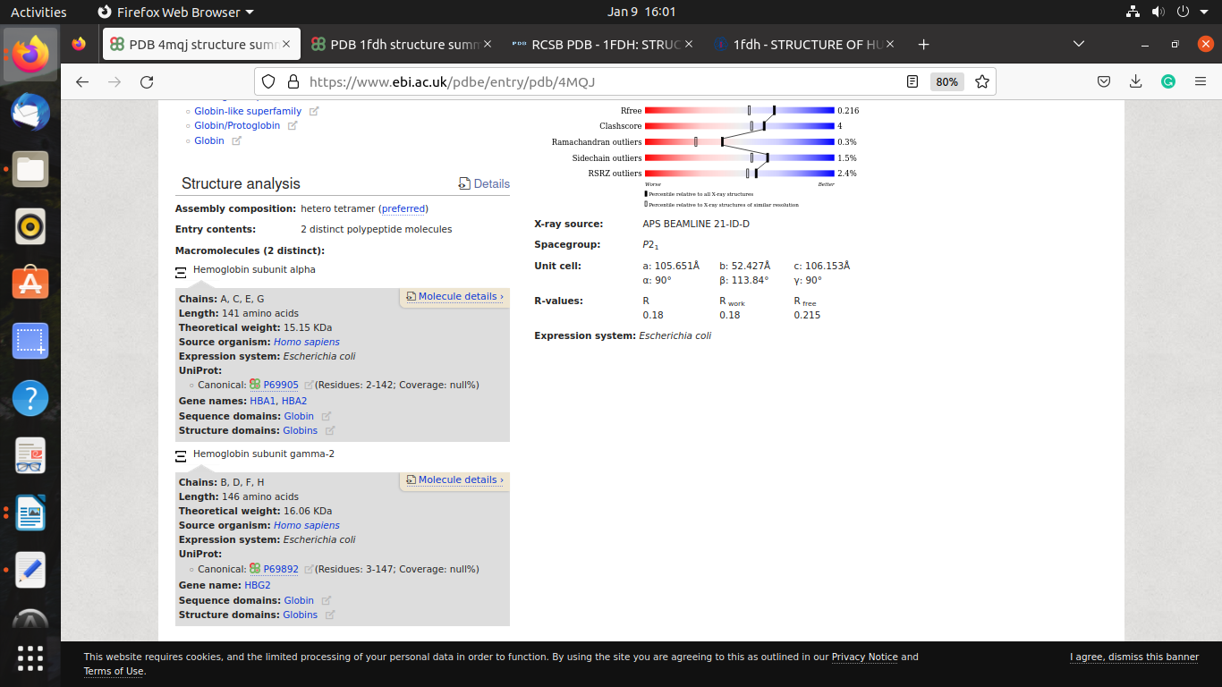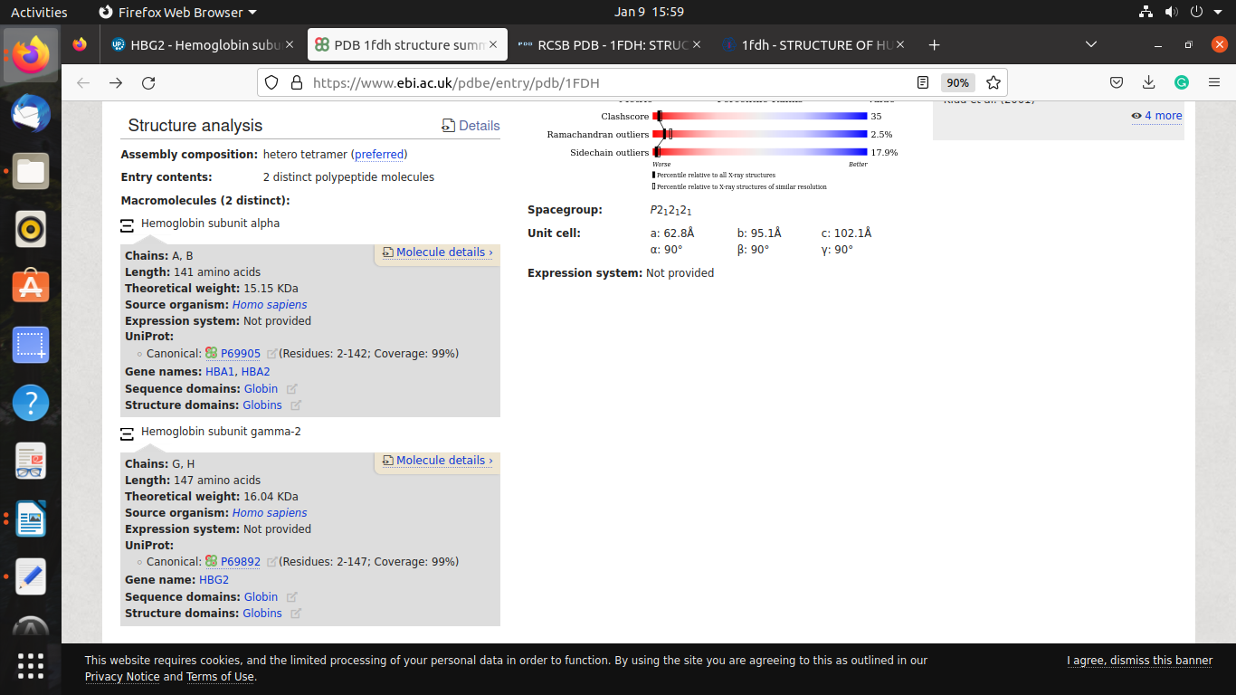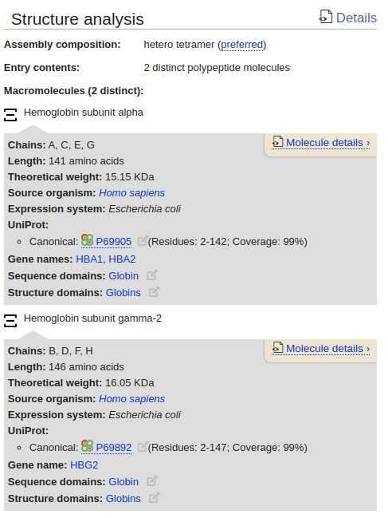

9. What is the chromosome location of Beta globulin chain?

10. Find the experimental annotation of the protein?

